**Faculty of Information Technology BIT (Hons) in Network and Mobile Computing IT22013: Web System and Technologies**

**Management system**

**Marketing for fruits, vegetables, meets and fish**

Lecturer -: Mr. Ashen Gunawardana

K.T.P.Warnakulasuriya

IT 2020101

2023.02.26

One drive link :- <https://horizoncampus-my.sharepoint.com/personal/kmtpwarnakulasuriya_horizoncampus_edu_lk/_layouts/15/onedrive.aspx?login_hint=kmtpwarnakulasuriya%40horizoncampus%2Eedu%2Elk&id=%2Fpersonal%2Fkmtpwarnakulasuriya%5Fhorizoncampus%5Fedu%5Flk%2FDocuments%2FIntake%2009%20%2D%20Web%20Systems%20and%20Technologies%20%E2%80%93%20IT2020101>

**Table of Contents**

1. Admin and User page common 5
   1. Login.php 5
   2. Logout.php 7
   3. Register.php 7
2. Admin pages 10
   1. Admin_page.php 10
   2. Admin_products.php 13
   3. Admin_orders.php 17
   4. Admin_users.php 19
   5. Admin_contacts.php 21
   6. Admin_header.php 23
   7. Admin_update_product.php 24
   8. Admin_update_profile.php 27
3. User pages 30
   1. Header.php 30
   2. Home.php 31
   3. shop.php 33
   4. orders.php 36
   5. about.php 38
   6. contact.php 40
   7. view_page.php 42
   8. wishlist 45
   9. search_page.php 48
   10. cart.php 52
   11. category.php 55
   12. checkout.php 58
   13. config.php 62
   14. footer.php 62
   15. user_profile_update.php 63
   16. shop_db.php 67
4. CSS Code 73
   1. Admin_style.css 73
   2. Components.css 79
   3. Style.css 90
   4. Script.js 107
5. User and Admin pages 108
   1. Register page 108
   2. Login 109
6. User page 110
   1. Home page 110
   2. Shop page 112
      1. Fruit page 113
      2. Vegetable page 114
      3. Fish page 114
      4. Meet page 115
   3. Order page 115
   4. About page 116
   5. Contact page 118
   6. Profile page 119
      1. Update profile page 120
   7. Search page 121
   8. Wishlist page 121
   9. Cart page 122
      1. Process checkout page 124
7. Admin page 125
   1. Home page 125
   2. Product page 125
   3. Order page 127
   4. Users page 127
   5. Massage page 128
   6. Profile page 129
      1. Update profile page 130

# **Admin and User page common**

## Login.php

<?php

@include 'config.php';

session_start();

if(isset($_POST['submit'])){

   $email = $_POST['email'];

   $email = filter_var($email, FILTER_SANITIZE_STRING);

   $pass = md5($_POST['pass']);

   $pass = filter_var($pass, FILTER_SANITIZE_STRING);

   $sql = "SELECT * FROM `users` WHERE email = ? AND password = ?";

   $stmt = $conn->prepare($sql);

   $stmt->execute([$email, $pass]);

   $rowCount = $stmt->rowCount();

   $row = $stmt->fetch(PDO::FETCH_ASSOC);

   if($rowCount > 0){

      if($row['user_type'] == 'admin'){

         $_SESSION['admin_id'] = $row['id'];

         header('location:admin_page.php');

      }elseif($row['user_type'] == 'user'){

         $_SESSION['user_id'] = $row['id'];

         header('location:home.php');

      }else{

         $message[] = 'no user found!';

      }

   }else{

      $message[] = 'incorrect email or password!';

   }

}

?>

<!DOCTYPE html>

<html lang="en">

<head>

   <meta charset="UTF-8">

   <meta http-equiv="X-UA-Compatible" content="IE=edge">

   <meta name="viewport" content="width=device-width, initial-scale=1.0">

   <title>login</title>

   <link rel="stylesheet" href="https://cdnjs.cloudflare.com/ajax/libs/font-awesome/6.1.1/css/all.min.css">

   <link rel="stylesheet" href="css/components.css">

</head>

<body>

<?php

if(isset($message)){

   foreach($message as $message){

      echo '

      <div class="message">

         <span>'.$message.'</span>

         <i class="fas fa-times" onclick="this.parentElement.remove();"></i>

      </div>

      ';

   }

}

?>

<section class="form-container">

   <form action="" method="POST">

      <h3>login now</h3>

      <input type="email" name="email" class="box" placeholder="enter your email" required>

      <input type="password" name="pass" class="box" placeholder="enter your password" required>

      <input type="submit" value="login now" class="btn" name="submit">

      <p>don't have an account? <a href="register.php">register now</a></p>

   </form>

</section>

</body>

</html>

## Logout.php

<?php

@include 'config.php';

session_start();

session_unset();

session_destroy();

header('location:login.php');

?>

## Register.php

<?php

include 'config.php';

if(isset($_POST['submit'])){

   $name = $_POST['name'];

   $name = filter_var($name, FILTER_SANITIZE_STRING);

   $email = $_POST['email'];

   $email = filter_var($email, FILTER_SANITIZE_STRING);

   $pass = md5($_POST['pass']);

   $pass = filter_var($pass, FILTER_SANITIZE_STRING);

   $cpass = md5($_POST['cpass']);

   $cpass = filter_var($cpass, FILTER_SANITIZE_STRING);

   $image = $_FILES['image']['name'];

   $image = filter_var($image, FILTER_SANITIZE_STRING);

   $image_size = $_FILES['image']['size'];

   $image_tmp_name = $_FILES['image']['tmp_name'];

   $image_folder = 'uploaded_img/'.$image;

   $select = $conn->prepare("SELECT * FROM `users` WHERE email = ?");

   $select->execute([$email]);

   if($select->rowCount() > 0){

      $message[] = 'user email already exist!';

   }else{

      if($pass != $cpass){

         $message[] = 'confirm password not matched!';

      }else{

         $insert = $conn->prepare("INSERT INTO `users`(name, email, password, image) VALUES(?,?,?,?)");

         $insert->execute([$name, $email, $pass, $image]);

         if($insert){

            if($image_size > 2000000){

               $message[] = 'image size is too large!';

            }else{

               move_uploaded_file($image_tmp_name, $image_folder);

               $message[] = 'registered successfully!';

               header('location:login.php');

            }

         }

      }

   }

}

?>

<!DOCTYPE html>

<html lang="en">

<head>

   <meta charset="UTF-8">

   <meta http-equiv="X-UA-Compatible" content="IE=edge">

   <meta name="viewport" content="width=device-width, initial-scale=1.0">

   <title>register</title>

   <link rel="stylesheet" href="https://cdnjs.cloudflare.com/ajax/libs/font-awesome/6.1.1/css/all.min.css">

   <link rel="stylesheet" href="css/components.css">

</head>

<body>

<?php

if(isset($message)){

   foreach($message as $message){

      echo '

      <div class="message">

         <span>'.$message.'</span>

         <i class="fas fa-times" onclick="this.parentElement.remove();"></i>

      </div>

      ';

   }

}

?>

<section class="form-container">

   <form action="" enctype="multipart/form-data" method="POST">

      <h3>register now</h3>

      <input type="text" name="name" class="box" placeholder="enter your name" required>

      <input type="email" name="email" class="box" placeholder="enter your email" required>

      <input type="password" name="pass" class="box" placeholder="enter your password" required>

      <input type="password" name="cpass" class="box" placeholder="confirm your password" required>

      <input type="file" name="image" class="box" required accept="image/jpg, image/jpeg, image/png">

      <input type="submit" value="register now" class="btn" name="submit">

      <p>already have an account? <a href="login.php">login now</a></p>

   </form>

</section>

</body>

</html>

# **Admin pages**

## Admin_page.php

<?php

@include 'config.php';

session_start();

$admin_id = $_SESSION['admin_id'];

if(!isset($admin_id)){

   header('location:login.php');

}

?>

<!DOCTYPE html>

<html lang="en">

<head>

   <meta charset="UTF-8">

   <meta http-equiv="X-UA-Compatible" content="IE=edge">

   <meta name="viewport" content="width=device-width, initial-scale=1.0">

   <title>admin page</title>

   <link rel="stylesheet" href="https://cdnjs.cloudflare.com/ajax/libs/font-awesome/6.1.1/css/all.min.css">

   <link rel="stylesheet" href="css/admin_style.css">

</head>

<body>

<?php include 'admin_header.php'; ?>

<section class="dashboard">

   <h1 class="title">dashboard</h1>

   <div class="box-container">

      <div class="box">

      <?php

         $total_pendings = 0;

         $select_pendings = $conn->prepare("SELECT * FROM `orders` WHERE payment_status = ?");

         $select_pendings->execute(['pending']);

         while($fetch_pendings = $select_pendings->fetch(PDO::FETCH_ASSOC)){

            $total_pendings += $fetch_pendings['total_price'];

         };

      ?>

      <h3>Rs. <?= $total_pendings; ?>/-</h3>

      <p>total pendings</p>

      <a href="admin_orders.php" class="btn">see orders</a>

      </div>

      <div class="box">

      <?php

         $total_completed = 0;

         $select_completed = $conn->prepare("SELECT * FROM `orders` WHERE payment_status = ?");

         $select_completed->execute(['completed']);

         while($fetch_completed = $select_completed->fetch(PDO::FETCH_ASSOC)){

            $total_completed += $fetch_completed['total_price'];

         };

      ?>

      <h3>Rs. <?= $total_completed; ?>/-</h3>

      <p>completed orders</p>

      <a href="admin_orders.php" class="btn">see orders</a>

      </div>

      <div class="box">

      <?php

         $select_orders = $conn->prepare("SELECT * FROM `orders`");

         $select_orders->execute();

         $number_of_orders = $select_orders->rowCount();

      ?>

      <h3><?= $number_of_orders; ?></h3>

      <p>orders placed</p>

      <a href="admin_orders.php" class="btn">see orders</a>

      </div>

      <div class="box">

      <?php

         $select_products = $conn->prepare("SELECT * FROM `products`");

         $select_products->execute();

         $number_of_products = $select_products->rowCount();

      ?>

      <h3><?= $number_of_products; ?></h3>

      <p>products added</p>

      <a href="admin_products.php" class="btn">see products</a>

      </div>

      <div class="box">

      <?php

         $select_users = $conn->prepare("SELECT * FROM `users` WHERE user_type = ?");

         $select_users->execute(['user']);

         $number_of_users = $select_users->rowCount();

      ?>

      <h3><?= $number_of_users; ?></h3>

      <p>total users</p>

      <a href="admin_users.php" class="btn">see accounts</a>

      </div>

      <div class="box">

      <?php

         $select_admins = $conn->prepare("SELECT * FROM `users` WHERE user_type = ?");

         $select_admins->execute(['admin']);

         $number_of_admins = $select_admins->rowCount();

      ?>

      <h3><?= $number_of_admins; ?></h3>

      <p>total admins</p>

      <a href="admin_users.php" class="btn">see accounts</a>

      </div>

      <div class="box">

      <?php

         $select_accounts = $conn->prepare("SELECT * FROM `users`");

         $select_accounts->execute();

         $number_of_accounts = $select_accounts->rowCount();

      ?>

      <h3><?= $number_of_accounts; ?></h3>

      <p>total accounts</p>

      <a href="admin_users.php" class="btn">see accounts</a>

      </div>

      <div class="box">

      <?php

         $select_messages = $conn->prepare("SELECT * FROM `message`");

         $select_messages->execute();

         $number_of_messages = $select_messages->rowCount();

      ?>

      <h3><?= $number_of_messages; ?></h3>

      <p>total messages</p>

      <a href="admin_contacts.php" class="btn">see messages</a>

      </div>

   </div>

</section>

<script src="js/script.js"></script>

</body>

</html>

## Admin_products.php

<?php

@include 'config.php';

session_start();

$admin_id = $_SESSION['admin_id'];

if(!isset($admin_id)){

   header('location:login.php');

};

if(isset($_POST['add_product'])){

   $name = $_POST['name'];

   $name = filter_var($name, FILTER_SANITIZE_STRING);

   $price = $_POST['price'];

   $price = filter_var($price, FILTER_SANITIZE_STRING);

   $category = $_POST['category'];

   $category = filter_var($category, FILTER_SANITIZE_STRING);

   $details = $_POST['details'];

   $details = filter_var($details, FILTER_SANITIZE_STRING);

   $image = $_FILES['image']['name'];

   $image = filter_var($image, FILTER_SANITIZE_STRING);

   $image_size = $_FILES['image']['size'];

   $image_tmp_name = $_FILES['image']['tmp_name'];

   $image_folder = 'uploaded_img/'.$image;

   $select_products = $conn->prepare("SELECT * FROM `products` WHERE name = ?");

   $select_products->execute([$name]);

   if($select_products->rowCount() > 0){

      $message[] = 'product name already exist!';

   }else{

      $insert_products = $conn->prepare("INSERT INTO `products`(name, category, details, price, image) VALUES(?,?,?,?,?)");

      $insert_products->execute([$name, $category, $details, $price, $image]);

      if($insert_products){

         if($image_size > 2000000){

            $message[] = 'image size is too large!';

         }else{

            move_uploaded_file($image_tmp_name, $image_folder);

            $message[] = 'new product added!';

         }

      }

   }

};

if(isset($_GET['delete'])){

   $delete_id = $_GET['delete'];

   $select_delete_image = $conn->prepare("SELECT image FROM `products` WHERE id = ?");

   $select_delete_image->execute([$delete_id]);

   $fetch_delete_image = $select_delete_image->fetch(PDO::FETCH_ASSOC);

   unlink('uploaded_img/'.$fetch_delete_image['image']);

   $delete_products = $conn->prepare("DELETE FROM `products` WHERE id = ?");

   $delete_products->execute([$delete_id]);

   $delete_wishlist = $conn->prepare("DELETE FROM `wishlist` WHERE pid = ?");

   $delete_wishlist->execute([$delete_id]);

   $delete_cart = $conn->prepare("DELETE FROM `cart` WHERE pid = ?");

   $delete_cart->execute([$delete_id]);

   header('location:admin_products.php');

}

?>

<!DOCTYPE html>

<html lang="en">

<head>

   <meta charset="UTF-8">

   <meta http-equiv="X-UA-Compatible" content="IE=edge">

   <meta name="viewport" content="width=device-width, initial-scale=1.0">

   <title>products</title>

   <link rel="stylesheet" href="https://cdnjs.cloudflare.com/ajax/libs/font-awesome/6.1.1/css/all.min.css">

   <link rel="stylesheet" href="css/admin_style.css">

</head>

<body>

<?php include 'admin_header.php'; ?>

<section class="add-products">

   <h1 class="title">add new product</h1>

   <form action="" method="POST" enctype="multipart/form-data">

      <div class="flex">

         <div class="inputBox">

         <input type="text" name="name" class="box" required placeholder="enter product name">

         <select name="category" class="box" required>

            <option value="" selected disabled>select category</option>

               <option value="vegitables">vegitables</option>

               <option value="fruits">fruits</option>

               <option value="meat">meat</option>

               <option value="fish">fish</option>

         </select>

         </div>

         <div class="inputBox">

         <input type="number" min="0" name="price" class="box" required placeholder="enter product price">

         <input type="file" name="image" required class="box" accept="image/jpg, image/jpeg, image/png">

         </div>

      </div>

      <textarea name="details" class="box" required placeholder="enter product details" cols="30" rows="10"></textarea>

      <input type="submit" class="btn" value="add product" name="add_product">

   </form>

</section>

<section class="show-products">

   <h1 class="title">products added</h1>

   <div class="box-container">

   <?php

      $show_products = $conn->prepare("SELECT * FROM `products`");

      $show_products->execute();

      if($show_products->rowCount() > 0){

         while($fetch_products = $show_products->fetch(PDO::FETCH_ASSOC)){

   ?>

   <div class="box">

      <div class="price">Rs. <?= $fetch_products['price']; ?>/-</div>

      <img src="uploaded_img/<?= $fetch_products['image']; ?>" alt="">

      <div class="name"><?= $fetch_products['name']; ?></div>

      <div class="cat"><?= $fetch_products['category']; ?></div>

      <div class="details"><?= $fetch_products['details']; ?></div>

      <div class="flex-btn">

         <a href="admin_update_product.php?update=<?= $fetch_products['id']; ?>" class="option-btn">update</a>

         <a href="admin_products.php?delete=<?= $fetch_products['id']; ?>" class="delete-btn" onclick="return confirm('delete this product?');">delete</a>

      </div>

   </div>

   <?php

      }

   }else{

      echo '<p class="empty">now products added yet!</p>';

   }

   ?>

   </div>

</section>

<script src="js/script.js"></script>

</body>

</html>

## Admin_orders.php

<?php

@include 'config.php';

session_start();

$admin_id = $_SESSION['admin_id'];

if(!isset($admin_id)){

   header('location:login.php');

};

if(isset($_POST['update_order'])){

   $order_id = $_POST['order_id'];

   $update_payment = $_POST['update_payment'];

   $update_payment = filter_var($update_payment, FILTER_SANITIZE_STRING);

   $update_orders = $conn->prepare("UPDATE `orders` SET payment_status = ? WHERE id = ?");

   $update_orders->execute([$update_payment, $order_id]);

   $message[] = 'payment has been updated!';

};

if(isset($_GET['delete'])){

   $delete_id = $_GET['delete'];

   $delete_orders = $conn->prepare("DELETE FROM `orders` WHERE id = ?");

   $delete_orders->execute([$delete_id]);

   header('location:admin_orders.php');

}

?>

<!DOCTYPE html>

<html lang="en">

<head>

   <meta charset="UTF-8">

   <meta http-equiv="X-UA-Compatible" content="IE=edge">

   <meta name="viewport" content="width=device-width, initial-scale=1.0">

   <title>orders</title>

   <link rel="stylesheet" href="https://cdnjs.cloudflare.com/ajax/libs/font-awesome/6.1.1/css/all.min.css">

   <link rel="stylesheet" href="css/admin_style.css">

</head>

<body>

<?php include 'admin_header.php'; ?>

<section class="placed-orders">

   <h1 class="title">placed orders</h1>

   <div class="box-container">

      <?php

         $select_orders = $conn->prepare("SELECT * FROM `orders`");

         $select_orders->execute();

         if($select_orders->rowCount() > 0){

            while($fetch_orders = $select_orders->fetch(PDO::FETCH_ASSOC)){

      ?>

      <div class="box">

         <p> user id : <span><?= $fetch_orders['user_id']; ?></span> </p>

         <p> placed on : <span><?= $fetch_orders['placed_on']; ?></span> </p>

         <p> name : <span><?= $fetch_orders['name']; ?></span> </p>

         <p> email : <span><?= $fetch_orders['email']; ?></span> </p>

         <p> number : <span><?= $fetch_orders['number']; ?></span> </p>

         <p> address : <span><?= $fetch_orders['address']; ?></span> </p>

         <p> total products : <span><?= $fetch_orders['total_products']; ?></span> </p>

         <p> total price : <span>Rs. <?= $fetch_orders['total_price']; ?>/-</span> </p>

         <p> payment method : <span><?= $fetch_orders['method']; ?></span> </p>

         <form action="" method="POST">

            <input type="hidden" name="order_id" value="<?= $fetch_orders['id']; ?>">

            <select name="update_payment" class="drop-down">

               <option value="" selected disabled><?= $fetch_orders['payment_status']; ?></option>

               <option value="pending">pending</option>

               <option value="completed">completed</option>

            </select>

            <div class="flex-btn">

               <input type="submit" name="update_order" class="option-btn" value="udate">

               <a href="admin_orders.php?delete=<?= $fetch_orders['id']; ?>" class="delete-btn" onclick="return confirm('delete this order?');">delete</a>

            </div>

         </form>

      </div>

      <?php

         }

      }else{

         echo '<p class="empty">no orders placed yet!</p>';

      }

      ?>

   </div>

</section>

<script src="js/script.js"></script>

</body>

</html>

## Admin_users.php

<?php

@include 'config.php';

session_start();

$admin_id = $_SESSION['admin_id'];

if(!isset($admin_id)){

   header('location:login.php');

};

if(isset($_GET['delete'])){

   $delete_id = $_GET['delete'];

   $delete_users = $conn->prepare("DELETE FROM `users` WHERE id = ?");

   $delete_users->execute([$delete_id]);

   header('location:admin_users.php');

}

?>

<!DOCTYPE html>

<html lang="en">

<head>

   <meta charset="UTF-8">

   <meta http-equiv="X-UA-Compatible" content="IE=edge">

   <meta name="viewport" content="width=device-width, initial-scale=1.0">

   <title>users</title>

   <link rel="stylesheet" href="https://cdnjs.cloudflare.com/ajax/libs/font-awesome/6.1.1/css/all.min.css">

   <link rel="stylesheet" href="css/admin_style.css">

</head>

<body>

<?php include 'admin_header.php'; ?>

<section class="user-accounts">

   <h1 class="title">user accounts</h1>

   <div class="box-container">

      <?php

         $select_users = $conn->prepare("SELECT * FROM `users`");

         $select_users->execute();

         while($fetch_users = $select_users->fetch(PDO::FETCH_ASSOC)){

      ?>

      <div class="box" style="<?php if($fetch_users['id'] == $admin_id){ echo 'display:none'; }; ?>">

         <img src="uploaded_img/<?= $fetch_users['image']; ?>" alt="">

         <p> user id : <span><?= $fetch_users['id']; ?></span></p>

         <p> username : <span><?= $fetch_users['name']; ?></span></p>

         <p> email : <span><?= $fetch_users['email']; ?></span></p>

         <p> user type : <span style=" color:<?php if($fetch_users['user_type'] == 'admin'){ echo 'orange'; }; ?>"><?= $fetch_users['user_type']; ?></span></p>

         <a href="admin_users.php?delete=<?= $fetch_users['id']; ?>" onclick="return confirm('delete this user?');" class="delete-btn">delete</a>

      </div>

      <?php

      }

      ?>

   </div>

</section>

<script src="js/script.js"></script>

</body>

</html>

## Admin_contacts.php

<?php

@include 'config.php';

session_start();

$admin_id = $_SESSION['admin_id'];

if(!isset($admin_id)){

   header('location:login.php');

};

if(isset($_GET['delete'])){

   $delete_id = $_GET['delete'];

   $delete_message = $conn->prepare("DELETE FROM `message` WHERE id = ?");

   $delete_message->execute([$delete_id]);

   header('location:admin_contacts.php');

}

?>

<!DOCTYPE html>

<html lang="en">

<head>

   <meta charset="UTF-8">

   <meta http-equiv="X-UA-Compatible" content="IE=edge">

   <meta name="viewport" content="width=device-width, initial-scale=1.0">

   <title>messages</title>

   <link rel="stylesheet" href="https://cdnjs.cloudflare.com/ajax/libs/font-awesome/6.1.1/css/all.min.css">

   <link rel="stylesheet" href="css/admin_style.css">

</head>

<body>

<?php include 'admin_header.php'; ?>

<section class="messages">

   <h1 class="title">messages</h1>

   <div class="box-container">

   <?php

      $select_message = $conn->prepare("SELECT * FROM `message`");

      $select_message->execute();

      if($select_message->rowCount() > 0){

         while($fetch_message = $select_message->fetch(PDO::FETCH_ASSOC)){

   ?>

   <div class="box">

      <p> user id : <span><?= $fetch_message['user_id']; ?></span> </p>

      <p> name : <span><?= $fetch_message['name']; ?></span> </p>

      <p> number : <span><?= $fetch_message['number']; ?></span> </p>

      <p> email : <span><?= $fetch_message['email']; ?></span> </p>

      <p> message : <span><?= $fetch_message['message']; ?></span> </p>

      <a href="admin_contacts.php?delete=<?= $fetch_message['id']; ?>" onclick="return confirm('delete this message?');" class="delete-btn">delete</a>

   </div>

   <?php

         }

      }else{

         echo '<p class="empty">you have no messages!</p>';

      }

   ?>

   </div>

</section>

<script src="js/script.js"></script>

</body>

</html>

## Admin_header.php

<?php

if(isset($message)){

   foreach($message as $message){

      echo '

      <div class="message">

         <span>'.$message.'</span>

         <i class="fas fa-times" onclick="this.parentElement.remove();"></i>

      </div>

      ';

   }

}

?>

<header class="header">

   <div class="flex">

      <a href="admin_page.php" class="logo">Admin<span>Panel</span></a>

      <nav class="navbar">

         <a href="admin_page.php">home</a>

         <a href="admin_products.php">products</a>

         <a href="admin_orders.php">orders</a>

         <a href="admin_users.php">users</a>

         <a href="admin_contacts.php">messages</a>

      </nav>

      <div class="icons">

         <div id="menu-btn" class="fas fa-bars"></div>

         <div id="user-btn" class="fas fa-user"></div>

      </div>

      <div class="profile">

         <?php

            $select_profile = $conn->prepare("SELECT * FROM `users` WHERE id = ?");

            $select_profile->execute([$admin_id]);

            $fetch_profile = $select_profile->fetch(PDO::FETCH_ASSOC);

         ?>

         <img src="uploaded_img/<?= $fetch_profile['image']; ?>" alt="">

         <p><?= $fetch_profile['name']; ?></p>

         <a href="admin_update_profile.php" class="btn">update profile</a>

         <a href="logout.php" class="delete-btn">logout</a>

         <div class="flex-btn">

            <a href="login.php" class="option-btn">login</a>

            <a href="register.php" class="option-btn">register</a>

         </div>

      </div>

   </div>

</header>

## Admin_update_product.php

<?php

@include 'config.php';

session_start();

$admin_id = $_SESSION['admin_id'];

if(!isset($admin_id)){

   header('location:login.php');

};

if(isset($_POST['update_product'])){

   $pid = $_POST['pid'];

   $name = $_POST['name'];

   $name = filter_var($name, FILTER_SANITIZE_STRING);

   $price = $_POST['price'];

   $price = filter_var($price, FILTER_SANITIZE_STRING);

   $category = $_POST['category'];

   $category = filter_var($category, FILTER_SANITIZE_STRING);

   $details = $_POST['details'];

   $details = filter_var($details, FILTER_SANITIZE_STRING);

   $image = $_FILES['image']['name'];

   $image = filter_var($image, FILTER_SANITIZE_STRING);

   $image_size = $_FILES['image']['size'];

   $image_tmp_name = $_FILES['image']['tmp_name'];

   $image_folder = 'uploaded_img/'.$image;

   $old_image = $_POST['old_image'];

   $update_product = $conn->prepare("UPDATE `products` SET name = ?, category = ?, details = ?, price = ? WHERE id = ?");

   $update_product->execute([$name, $category, $details, $price, $pid]);

   $message[] = 'product updated successfully!';

   if(!empty($image)){

      if($image_size > 2000000){

         $message[] = 'image size is too large!';

      }else{

         $update_image = $conn->prepare("UPDATE `products` SET image = ? WHERE id = ?");

         $update_image->execute([$image, $pid]);

         if($update_image){

            move_uploaded_file($image_tmp_name, $image_folder);

            unlink('uploaded_img/'.$old_image);

            $message[] = 'image updated successfully!';

         }

      }

   }

}

?>

<!DOCTYPE html>

<html lang="en">

<head>

   <meta charset="UTF-8">

   <meta http-equiv="X-UA-Compatible" content="IE=edge">

   <meta name="viewport" content="width=device-width, initial-scale=1.0">

   <title>update products</title>

   <link rel="stylesheet" href="https://cdnjs.cloudflare.com/ajax/libs/font-awesome/6.1.1/css/all.min.css">

   <link rel="stylesheet" href="css/admin_style.css">

</head>

<body>

<?php include 'admin_header.php'; ?>

<section class="update-product">

   <h1 class="title">update product</h1>

   <?php

      $update_id = $_GET['update'];

      $select_products = $conn->prepare("SELECT * FROM `products` WHERE id = ?");

      $select_products->execute([$update_id]);

      if($select_products->rowCount() > 0){

         while($fetch_products = $select_products->fetch(PDO::FETCH_ASSOC)){

   ?>

   <form action="" method="post" enctype="multipart/form-data">

      <input type="hidden" name="old_image" value="<?= $fetch_products['image']; ?>">

      <input type="hidden" name="pid" value="<?= $fetch_products['id']; ?>">

      <img src="uploaded_img/<?= $fetch_products['image']; ?>" alt="">

      <input type="text" name="name" placeholder="enter product name" required class="box" value="<?= $fetch_products['name']; ?>">

      <input type="number" name="price" min="0" placeholder="enter product price" required class="box" value="<?= $fetch_products['price']; ?>">

      <select name="category" class="box" required>

         <option selected><?= $fetch_products['category']; ?></option>

         <option value="vegitables">vegitables</option>

         <option value="fruits">fruits</option>

         <option value="meat">meat</option>

         <option value="fish">fish</option>

      </select>

      <textarea name="details" required placeholder="enter product details" class="box" cols="30" rows="10"><?= $fetch_products['details']; ?></textarea>

      <input type="file" name="image" class="box" accept="image/jpg, image/jpeg, image/png">

      <div class="flex-btn">

         <input type="submit" class="btn" value="update product" name="update_product">

         <a href="admin_products.php" class="option-btn">go back</a>

      </div>

   </form>

   <?php

         }

      }else{

         echo '<p class="empty">no products found!</p>';

      }

   ?>

</section>

<script src="js/script.js"></script>

</body>

</html>

## Admin_update_profile.php

<?php

@include 'config.php';

session_start();

$admin_id = $_SESSION['admin_id'];

if(!isset($admin_id)){

   header('location:login.php');

};

if(isset($_POST['update_profile'])){

   $name = $_POST['name'];

   $name = filter_var($name, FILTER_SANITIZE_STRING);

   $email = $_POST['email'];

   $email = filter_var($email, FILTER_SANITIZE_STRING);

   $update_profile = $conn->prepare("UPDATE `users` SET name = ?, email = ? WHERE id = ?");

   $update_profile->execute([$name, $email, $admin_id]);

   $image = $_FILES['image']['name'];

   $image = filter_var($image, FILTER_SANITIZE_STRING);

   $image_size = $_FILES['image']['size'];

   $image_tmp_name = $_FILES['image']['tmp_name'];

   $image_folder = 'uploaded_img/'.$image;

   $old_image = $_POST['old_image'];

   if(!empty($image)){

      if($image_size > 2000000){

         $message[] = 'image size is too large!';

      }else{

         $update_image = $conn->prepare("UPDATE `users` SET image = ? WHERE id = ?");

         $update_image->execute([$image, $admin_id]);

         if($update_image){

            move_uploaded_file($image_tmp_name, $image_folder);

            unlink('uploaded_img/'.$old_image);

            $message[] = 'image updated successfully!';

         };

      };

   };

   $old_pass = $_POST['old_pass'];

   $update_pass = md5($_POST['update_pass']);

   $update_pass = filter_var($update_pass, FILTER_SANITIZE_STRING);

   $new_pass = md5($_POST['new_pass']);

   $new_pass = filter_var($new_pass, FILTER_SANITIZE_STRING);

   $confirm_pass = md5($_POST['confirm_pass']);

   $confirm_pass = filter_var($confirm_pass, FILTER_SANITIZE_STRING);

   if(!empty($update_pass) AND !empty($new_pass) AND !empty($confirm_pass)){

      if($update_pass != $old_pass){

         $message[] = 'old password not matched!';

      }elseif($new_pass != $confirm_pass){

         $message[] = 'confirm password not matched!';

      }else{

         $update_pass_query = $conn->prepare("UPDATE `users` SET password = ? WHERE id = ?");

         $update_pass_query->execute([$confirm_pass, $admin_id]);

         $message[] = 'password updated successfully!';

      }

   }

}

?>

<!DOCTYPE html>

<html lang="en">

<head>

   <meta charset="UTF-8">

   <meta http-equiv="X-UA-Compatible" content="IE=edge">

   <meta name="viewport" content="width=device-width, initial-scale=1.0">

   <title>update admin profile</title>

   <link rel="stylesheet" href="https://cdnjs.cloudflare.com/ajax/libs/font-awesome/6.1.1/css/all.min.css">

   <link rel="stylesheet" href="css/components.css">

</head>

<body>

<?php include 'admin_header.php'; ?>

<section class="update-profile">

   <h1 class="title">update profile</h1>

   <form action="" method="POST" enctype="multipart/form-data">

      <img src="uploaded_img/<?= $fetch_profile['image']; ?>" alt="">

      <div class="flex">

         <div class="inputBox">

            <span>username :</span>

            <input type="text" name="name" value="<?= $fetch_profile['name']; ?>" placeholder="update username" required class="box">

            <span>email :</span>

            <input type="email" name="email" value="<?= $fetch_profile['email']; ?>" placeholder="update email" required class="box">

            <span>update pic :</span>

            <input type="file" name="image" accept="image/jpg, image/jpeg, image/png" class="box">

            <input type="hidden" name="old_image" value="<?= $fetch_profile['image']; ?>">

         </div>

         <div class="inputBox">

            <input type="hidden" name="old_pass" value="<?= $fetch_profile['password']; ?>">

            <span>old password :</span>

            <input type="password" name="update_pass" placeholder="enter previous password" class="box">

            <span>new password :</span>

            <input type="password" name="new_pass" placeholder="enter new password" class="box">

            <span>confirm password :</span>

            <input type="password" name="confirm_pass" placeholder="confirm new password" class="box">

         </div>

      </div>

      <div class="flex-btn">

         <input type="submit" class="btn" value="update profile" name="update_profile">

         <a href="admin_page.php" class="option-btn">go back</a>

      </div>

   </form>

</section>

<script src="js/script.js"></script>

</body>

</html>

# **User pages**

## Header.php

<?php

if(isset($message)){

   foreach($message as $message){

      echo '

      <div class="message">

         <span>'.$message.'</span>

         <i class="fas fa-times" onclick="this.parentElement.remove();"></i>

      </div>

      ';

   }

}

?>

<header class="header">

   <div class="flex">

      <a href="admin_page.php" class="logo">Admin<span></span></a>

      <nav class="navbar">

         <a href="home.php">home</a>

         <a href="shop.php">shop</a>

         <a href="orders.php">orders</a>

         <a href="about.php">about</a>

         <a href="contact.php">contact</a>

      </nav>

      <div class="icons">

         <div id="menu-btn" class="fas fa-bars"></div>

         <div id="user-btn" class="fas fa-user"></div>

         <a href="search_page.php" class="fas fa-search"></a>

         <?php

            $count_cart_items = $conn->prepare("SELECT * FROM `cart` WHERE user_id = ?");

            $count_cart_items->execute([$user_id]);

            $count_wishlist_items = $conn->prepare("SELECT * FROM `wishlist` WHERE user_id = ?");

            $count_wishlist_items->execute([$user_id]);

         ?>

         <a href="wishlist.php"><i class="fas fa-heart"></i><span>(<?= $count_wishlist_items->rowCount(); ?>)</span></a>

         <a href="cart.php"><i class="fas fa-shopping-cart"></i><span>(<?= $count_cart_items->rowCount(); ?>)</span></a>

      </div>

      <div class="profile">

         <?php

            $select_profile = $conn->prepare("SELECT * FROM `users` WHERE id = ?");

            $select_profile->execute([$user_id]);

            $fetch_profile = $select_profile->fetch(PDO::FETCH_ASSOC);

         ?>

         <img src="uploaded_img/<?= $fetch_profile['image']; ?>" alt="">

         <p><?= $fetch_profile['name']; ?></p>

         <a href="user_profile_update.php" class="btn">update profile</a>

         <a href="logout.php" class="delete-btn">logout</a>

         <div class="flex-btn">

            <a href="login.php" class="option-btn">login</a>

            <a href="register.php" class="option-btn">register</a>

         </div>

      </div>

   </div>

</header>

## Home.php

<?php

if(isset($message)){

   foreach($message as $message){

      echo '

      <div class="message">

         <span>'.$message.'</span>

         <i class="fas fa-times" onclick="this.parentElement.remove();"></i>

      </div>

      ';

   }

}

?>

<header class="header">

   <div class="flex">

      <a href="admin_page.php" class="logo">Admin<span></span></a>

      <nav class="navbar">

         <a href="home.php">home</a>

         <a href="shop.php">shop</a>

         <a href="orders.php">orders</a>

         <a href="about.php">about</a>

         <a href="contact.php">contact</a>

      </nav>

      <div class="icons">

         <div id="menu-btn" class="fas fa-bars"></div>

         <div id="user-btn" class="fas fa-user"></div>

         <a href="search_page.php" class="fas fa-search"></a>

         <?php

            $count_cart_items = $conn->prepare("SELECT * FROM `cart` WHERE user_id = ?");

            $count_cart_items->execute([$user_id]);

            $count_wishlist_items = $conn->prepare("SELECT * FROM `wishlist` WHERE user_id = ?");

            $count_wishlist_items->execute([$user_id]);

         ?>

         <a href="wishlist.php"><i class="fas fa-heart"></i><span>(<?= $count_wishlist_items->rowCount(); ?>)</span></a>

         <a href="cart.php"><i class="fas fa-shopping-cart"></i><span>(<?= $count_cart_items->rowCount(); ?>)</span></a>

      </div>

      <div class="profile">

         <?php

            $select_profile = $conn->prepare("SELECT * FROM `users` WHERE id = ?");

            $select_profile->execute([$user_id]);

            $fetch_profile = $select_profile->fetch(PDO::FETCH_ASSOC);

         ?>

         <img src="uploaded_img/<?= $fetch_profile['image']; ?>" alt="">

         <p><?= $fetch_profile['name']; ?></p>

         <a href="user_profile_update.php" class="btn">update profile</a>

         <a href="logout.php" class="delete-btn">logout</a>

         <div class="flex-btn">

            <a href="login.php" class="option-btn">login</a>

            <a href="register.php" class="option-btn">register</a>

         </div>

      </div>

   </div>

</header>

## shop.php

<?php

@include 'config.php';

session_start();

$user_id = $_SESSION['user_id'];

if(!isset($user_id)){

   header('location:login.php');

};

if(isset($_POST['add_to_wishlist'])){

   $pid = $_POST['pid'];

   $pid = filter_var($pid, FILTER_SANITIZE_STRING);

   $p_name = $_POST['p_name'];

   $p_name = filter_var($p_name, FILTER_SANITIZE_STRING);

   $p_price = $_POST['p_price'];

   $p_price = filter_var($p_price, FILTER_SANITIZE_STRING);

   $p_image = $_POST['p_image'];

   $p_image = filter_var($p_image, FILTER_SANITIZE_STRING);

   $check_wishlist_numbers = $conn->prepare("SELECT * FROM `wishlist` WHERE name = ? AND user_id = ?");

   $check_wishlist_numbers->execute([$p_name, $user_id]);

   $check_cart_numbers = $conn->prepare("SELECT * FROM `cart` WHERE name = ? AND user_id = ?");

   $check_cart_numbers->execute([$p_name, $user_id]);

   if($check_wishlist_numbers->rowCount() > 0){

      $message[] = 'already added to wishlist!';

   }elseif($check_cart_numbers->rowCount() > 0){

      $message[] = 'already added to cart!';

   }else{

      $insert_wishlist = $conn->prepare("INSERT INTO `wishlist`(user_id, pid, name, price, image) VALUES(?,?,?,?,?)");

      $insert_wishlist->execute([$user_id, $pid, $p_name, $p_price, $p_image]);

      $message[] = 'added to wishlist!';

   }

}

if(isset($_POST['add_to_cart'])){

   $pid = $_POST['pid'];

   $pid = filter_var($pid, FILTER_SANITIZE_STRING);

   $p_name = $_POST['p_name'];

   $p_name = filter_var($p_name, FILTER_SANITIZE_STRING);

   $p_price = $_POST['p_price'];

   $p_price = filter_var($p_price, FILTER_SANITIZE_STRING);

   $p_image = $_POST['p_image'];

   $p_image = filter_var($p_image, FILTER_SANITIZE_STRING);

   $p_qty = $_POST['p_qty'];

   $p_qty = filter_var($p_qty, FILTER_SANITIZE_STRING);

   $check_cart_numbers = $conn->prepare("SELECT * FROM `cart` WHERE name = ? AND user_id = ?");

   $check_cart_numbers->execute([$p_name, $user_id]);

   if($check_cart_numbers->rowCount() > 0){

      $message[] = 'already added to cart!';

   }else{

      $check_wishlist_numbers = $conn->prepare("SELECT * FROM `wishlist` WHERE name = ? AND user_id = ?");

      $check_wishlist_numbers->execute([$p_name, $user_id]);

      if($check_wishlist_numbers->rowCount() > 0){

         $delete_wishlist = $conn->prepare("DELETE FROM `wishlist` WHERE name = ? AND user_id = ?");

         $delete_wishlist->execute([$p_name, $user_id]);

      }

      $insert_cart = $conn->prepare("INSERT INTO `cart`(user_id, pid, name, price, quantity, image) VALUES(?,?,?,?,?,?)");

      $insert_cart->execute([$user_id, $pid, $p_name, $p_price, $p_qty, $p_image]);

      $message[] = 'added to cart!';

   }

}

?>

<!DOCTYPE html>

<html lang="en">

<head>

   <meta charset="UTF-8">

   <meta http-equiv="X-UA-Compatible" content="IE=edge">

   <meta name="viewport" content="width=device-width, initial-scale=1.0">

   <title>shop</title>

   <link rel="stylesheet" href="https://cdnjs.cloudflare.com/ajax/libs/font-awesome/6.1.1/css/all.min.css">

   <link rel="stylesheet" href="css/style.css">

</head>

<body>

<?php include 'header.php'; ?>

<section class="p-category">

   <a href="category.php?category=fruits">fruits</a>

   <a href="category.php?category=vegitables">vegitables</a>

   <a href="category.php?category=fish">fish</a>

   <a href="category.php?category=meat">meat</a>

</section>

<section class="products">

   <h1 class="title">latest products</h1>

   <div class="box-container">

   <?php

      $select_products = $conn->prepare("SELECT * FROM `products`");

      $select_products->execute();

      if($select_products->rowCount() > 0){

         while($fetch_products = $select_products->fetch(PDO::FETCH_ASSOC)){

   ?>

   <form action="" class="box" method="POST">

      <div class="price">Rs. <span><?= $fetch_products['price']; ?></span>/-</div>

      <a href="view_page.php?pid=<?= $fetch_products['id']; ?>" class="fas fa-eye"></a>

      <img src="uploaded_img/<?= $fetch_products['image']; ?>" alt="">

      <div class="name"><?= $fetch_products['name']; ?></div>

      <input type="hidden" name="pid" value="<?= $fetch_products['id']; ?>">

      <input type="hidden" name="p_name" value="<?= $fetch_products['name']; ?>">

      <input type="hidden" name="p_price" value="<?= $fetch_products['price']; ?>">

      <input type="hidden" name="p_image" value="<?= $fetch_products['image']; ?>">

      <input type="number" min="1" value="1" name="p_qty" class="qty">

      <input type="submit" value="add to wishlist" class="option-btn" name="add_to_wishlist">

      <input type="submit" value="add to cart" class="btn" name="add_to_cart">

   </form>

   <?php

      }

   }else{

      echo '<p class="empty">no products added yet!</p>';

   }

   ?>

   </div>

</section>

<?php include 'footer.php'; ?>

<script src="js/script.js"></script>

</body>

</html>

## orders.php

<?php

@include 'config.php';

session_start();

$user_id = $_SESSION['user_id'];

if(!isset($user_id)){

   header('location:login.php');

}

?>

<!DOCTYPE html>

<html lang="en">

<head>

   <meta charset="UTF-8">

   <meta http-equiv="X-UA-Compatible" content="IE=edge">

   <meta name="viewport" content="width=device-width, initial-scale=1.0">

   <title>orders</title>

   <link rel="stylesheet" href="https://cdnjs.cloudflare.com/ajax/libs/font-awesome/6.1.1/css/all.min.css">

   <link rel="stylesheet" href="css/style.css">

</head>

<body>

<?php include 'header.php'; ?>

<section class="placed-orders">

   <h1 class="title">placed orders</h1>

   <div class="box-container">

   <?php

      $select_orders = $conn->prepare("SELECT * FROM `orders` WHERE user_id = ?");

      $select_orders->execute([$user_id]);

      if($select_orders->rowCount() > 0){

         while($fetch_orders = $select_orders->fetch(PDO::FETCH_ASSOC)){

   ?>

   <div class="box">

      <p> placed on : <span><?= $fetch_orders['placed_on']; ?></span> </p>

      <p> name : <span><?= $fetch_orders['name']; ?></span> </p>

      <p> number : <span><?= $fetch_orders['number']; ?></span> </p>

      <p> email : <span><?= $fetch_orders['email']; ?></span> </p>

      <p> address : <span><?= $fetch_orders['address']; ?></span> </p>

      <p> payment method : <span><?= $fetch_orders['method']; ?></span> </p>

      <p> your orders : <span><?= $fetch_orders['total_products']; ?></span> </p>

      <p> total price : <span>Rs. <?= $fetch_orders['total_price']; ?>/-</span> </p>

      <p> payment status : <span style="color:<?php if($fetch_orders['payment_status'] == 'pending'){ echo 'red'; }else{ echo 'green'; }; ?>"><?= $fetch_orders['payment_status']; ?></span> </p>

   </div>

   <?php

      }

   }else{

      echo '<p class="empty">no orders placed yet!</p>';

   }

   ?>

   </div>

</section>

<?php include 'footer.php'; ?>

<script src="js/script.js"></script>

</body>

</html>

## about.php

<?php

@include 'config.php';

session_start();

$user_id = $_SESSION['user_id'];

if(!isset($user_id)){

   header('location:login.php');

}

?>

<!DOCTYPE html>

<html lang="en">

<head>

   <meta charset="UTF-8">

   <meta http-equiv="X-UA-Compatible" content="IE=edge">

   <meta name="viewport" content="width=device-width, initial-scale=1.0">

   <title>about</title>

   <link rel="stylesheet" href="https://cdnjs.cloudflare.com/ajax/libs/font-awesome/6.1.1/css/all.min.css">

   <link rel="stylesheet" href="css/style.css">

</head>

<body>

<?php include 'header.php'; ?>

<section class="about">

   <div class="row">

      <div class="box">

         <img src="images/about-img-1.png" alt="">

         <h3>why choose us?</h3>

         <p>..................................................................................</p>

         <a href="contact.php" class="btn">contact us</a>

      </div>

      <div class="box">

         <img src="images/about-img-2.png" alt="">

         <h3>what we provide?</h3>

         <p>...................................................................................</p>

         <a href="shop.php" class="btn">our shop</a>

      </div>

   </div>

</section>

<section class="reviews">

   <h1 class="title">clients reivews</h1>

   <div class="box-container">

      <div class="box">

         <img src="images/client pic.jpg" alt="">

         <p>My name is Tharaka Prasad. This online shop is good. It has good products </p>

         <div class="stars">

            <i class="fas fa-star"></i>

            <i class="fas fa-star"></i>

            <i class="fas fa-star"></i>

            <i class="fas fa-star"></i>

            <i class="fas fa-star-half-alt"></i>

         </div>

         <h3>Tharaka Prasad</h3>

      </div>

         </div>

      </div>

   </div>

</section>

<?php include 'footer.php'; ?>

<script src="js/script.js"></script>

</body>

</html>

## contact.php

<?php

@include 'config.php';

session_start();

$user_id = $_SESSION['user_id'];

if(!isset($user_id)){

   header('location:login.php');

};

if(isset($_POST['send'])){

   $name = $_POST['name'];

   $name = filter_var($name, FILTER_SANITIZE_STRING);

   $email = $_POST['email'];

   $email = filter_var($email, FILTER_SANITIZE_STRING);

   $number = $_POST['number'];

   $number = filter_var($number, FILTER_SANITIZE_STRING);

   $msg = $_POST['msg'];

   $msg = filter_var($msg, FILTER_SANITIZE_STRING);

   $select_message = $conn->prepare("SELECT * FROM `message` WHERE name = ? AND email = ? AND number = ? AND message = ?");

   $select_message->execute([$name, $email, $number, $msg]);

   if($select_message->rowCount() > 0){

      $message[] = 'already sent message!';

   }else{

      $insert_message = $conn->prepare("INSERT INTO `message`(user_id, name, email, number, message) VALUES(?,?,?,?,?)");

      $insert_message->execute([$user_id, $name, $email, $number, $msg]);

      $message[] = 'sent message successfully!';

   }

}

?>

<!DOCTYPE html>

<html lang="en">

<head>

   <meta charset="UTF-8">

   <meta http-equiv="X-UA-Compatible" content="IE=edge">

   <meta name="viewport" content="width=device-width, initial-scale=1.0">

   <title>contact</title>

   <link rel="stylesheet" href="https://cdnjs.cloudflare.com/ajax/libs/font-awesome/6.1.1/css/all.min.css">

   <link rel="stylesheet" href="css/style.css">

</head>

<body>

<?php include 'header.php'; ?>

<section class="contact">

   <h1 class="title">get in touch</h1>

   <form action="" method="POST">

      <input type="text" name="name" class="box" required placeholder="enter your name">

      <input type="email" name="email" class="box" required placeholder="enter your email">

      <input type="number" name="number" min="0" class="box" required placeholder="enter your number">

      <textarea name="msg" class="box" required placeholder="enter your message" cols="30" rows="10"></textarea>

      <input type="submit" value="send message" class="btn" name="send">

   </form>

</section>

<?php include 'footer.php'; ?>

<script src="js/script.js"></script>

</body>

</html>

## view_page.php

<?php

@include 'config.php';

session_start();

$user_id = $_SESSION['user_id'];

if(!isset($user_id)){

   header('location:login.php');

};

if(isset($_POST['add_to_wishlist'])){

   $pid = $_POST['pid'];

   $pid = filter_var($pid, FILTER_SANITIZE_STRING);

   $p_name = $_POST['p_name'];

   $p_name = filter_var($p_name, FILTER_SANITIZE_STRING);

   $p_price = $_POST['p_price'];

   $p_price = filter_var($p_price, FILTER_SANITIZE_STRING);

   $p_image = $_POST['p_image'];

   $p_image = filter_var($p_image, FILTER_SANITIZE_STRING);

   $check_wishlist_numbers = $conn->prepare("SELECT * FROM `wishlist` WHERE name = ? AND user_id = ?");

   $check_wishlist_numbers->execute([$p_name, $user_id]);

   $check_cart_numbers = $conn->prepare("SELECT * FROM `cart` WHERE name = ? AND user_id = ?");

   $check_cart_numbers->execute([$p_name, $user_id]);

   if($check_wishlist_numbers->rowCount() > 0){

      $message[] = 'already added to wishlist!';

   }elseif($check_cart_numbers->rowCount() > 0){

      $message[] = 'already added to cart!';

   }else{

      $insert_wishlist = $conn->prepare("INSERT INTO `wishlist`(user_id, pid, name, price, image) VALUES(?,?,?,?,?)");

      $insert_wishlist->execute([$user_id, $pid, $p_name, $p_price, $p_image]);

      $message[] = 'added to wishlist!';

   }

}

if(isset($_POST['add_to_cart'])){

   $pid = $_POST['pid'];

   $pid = filter_var($pid, FILTER_SANITIZE_STRING);

   $p_name = $_POST['p_name'];

   $p_name = filter_var($p_name, FILTER_SANITIZE_STRING);

   $p_price = $_POST['p_price'];

   $p_price = filter_var($p_price, FILTER_SANITIZE_STRING);

   $p_image = $_POST['p_image'];

   $p_image = filter_var($p_image, FILTER_SANITIZE_STRING);

   $p_qty = $_POST['p_qty'];

   $p_qty = filter_var($p_qty, FILTER_SANITIZE_STRING);

   $check_cart_numbers = $conn->prepare("SELECT * FROM `cart` WHERE name = ? AND user_id = ?");

   $check_cart_numbers->execute([$p_name, $user_id]);

   if($check_cart_numbers->rowCount() > 0){

      $message[] = 'already added to cart!';

   }else{

      $check_wishlist_numbers = $conn->prepare("SELECT * FROM `wishlist` WHERE name = ? AND user_id = ?");

      $check_wishlist_numbers->execute([$p_name, $user_id]);

      if($check_wishlist_numbers->rowCount() > 0){

         $delete_wishlist = $conn->prepare("DELETE FROM `wishlist` WHERE name = ? AND user_id = ?");

         $delete_wishlist->execute([$p_name, $user_id]);

      }

      $insert_cart = $conn->prepare("INSERT INTO `cart`(user_id, pid, name, price, quantity, image) VALUES(?,?,?,?,?,?)");

      $insert_cart->execute([$user_id, $pid, $p_name, $p_price, $p_qty, $p_image]);

      $message[] = 'added to cart!';

   }

}

?>

<!DOCTYPE html>

<html lang="en">

<head>

   <meta charset="UTF-8">

   <meta http-equiv="X-UA-Compatible" content="IE=edge">

   <meta name="viewport" content="width=device-width, initial-scale=1.0">

   <title>quick view</title>

   <link rel="stylesheet" href="https://cdnjs.cloudflare.com/ajax/libs/font-awesome/6.1.1/css/all.min.css">

   <link rel="stylesheet" href="css/style.css">

</head>

<body>

<?php include 'header.php'; ?>

<section class="quick-view">

   <h1 class="title">quick view</h1>

   <?php

      $pid = $_GET['pid'];

      $select_products = $conn->prepare("SELECT * FROM `products` WHERE id = ?");

      $select_products->execute([$pid]);

      if($select_products->rowCount() > 0){

         while($fetch_products = $select_products->fetch(PDO::FETCH_ASSOC)){

   ?>

   <form action="" class="box" method="POST">

      <div class="price">Rs. <span><?= $fetch_products['price']; ?></span>/-</div>

      <img src="uploaded_img/<?= $fetch_products['image']; ?>" alt="">

      <div class="name"><?= $fetch_products['name']; ?></div>

      <div class="details"><?= $fetch_products['details']; ?></div>

      <input type="hidden" name="pid" value="<?= $fetch_products['id']; ?>">

      <input type="hidden" name="p_name" value="<?= $fetch_products['name']; ?>">

      <input type="hidden" name="p_price" value="<?= $fetch_products['price']; ?>">

      <input type="hidden" name="p_image" value="<?= $fetch_products['image']; ?>">

      <input type="number" min="1" value="1" name="p_qty" class="qty">

      <input type="submit" value="add to wishlist" class="option-btn" name="add_to_wishlist">

      <input type="submit" value="add to cart" class="btn" name="add_to_cart">

   </form>

   <?php

         }

      }else{

         echo '<p class="empty">no products added yet!</p>';

      }

   ?>

</section>

<?php include 'footer.php'; ?>

<script src="js/script.js"></script>

</body>

</html>

## Wishlist.php

<?php

@include 'config.php';

session_start();

$user_id = $_SESSION['user_id'];

if(!isset($user_id)){

   header('location:login.php');

};

if(isset($_POST['add_to_cart'])){

   $pid = $_POST['pid'];

   $pid = filter_var($pid, FILTER_SANITIZE_STRING);

   $p_name = $_POST['p_name'];

   $p_name = filter_var($p_name, FILTER_SANITIZE_STRING);

   $p_price = $_POST['p_price'];

   $p_price = filter_var($p_price, FILTER_SANITIZE_STRING);

   $p_image = $_POST['p_image'];

   $p_image = filter_var($p_image, FILTER_SANITIZE_STRING);

   $p_qty = $_POST['p_qty'];

   $p_qty = filter_var($p_qty, FILTER_SANITIZE_STRING);

   $check_cart_numbers = $conn->prepare("SELECT * FROM `cart` WHERE name = ? AND user_id = ?");

   $check_cart_numbers->execute([$p_name, $user_id]);

   if($check_cart_numbers->rowCount() > 0){

      $message[] = 'already added to cart!';

   }else{

      $check_wishlist_numbers = $conn->prepare("SELECT * FROM `wishlist` WHERE name = ? AND user_id = ?");

      $check_wishlist_numbers->execute([$p_name, $user_id]);

      if($check_wishlist_numbers->rowCount() > 0){

         $delete_wishlist = $conn->prepare("DELETE FROM `wishlist` WHERE name = ? AND user_id = ?");

         $delete_wishlist->execute([$p_name, $user_id]);

      }

      $insert_cart = $conn->prepare("INSERT INTO `cart`(user_id, pid, name, price, quantity, image) VALUES(?,?,?,?,?,?)");

      $insert_cart->execute([$user_id, $pid, $p_name, $p_price, $p_qty, $p_image]);

      $message[] = 'added to cart!';

   }

}

if(isset($_GET['delete'])){

   $delete_id = $_GET['delete'];

   $delete_wishlist_item = $conn->prepare("DELETE FROM `wishlist` WHERE id = ?");

   $delete_wishlist_item->execute([$delete_id]);

   header('location:wishlist.php');

}

if(isset($_GET['delete_all'])){

   $delete_wishlist_item = $conn->prepare("DELETE FROM `wishlist` WHERE user_id = ?");

   $delete_wishlist_item->execute([$user_id]);

   header('location:wishlist.php');

}

?>

<!DOCTYPE html>

<html lang="en">

<head>

   <meta charset="UTF-8">

   <meta http-equiv="X-UA-Compatible" content="IE=edge">

   <meta name="viewport" content="width=device-width, initial-scale=1.0">

   <title>wishlist</title>

   <link rel="stylesheet" href="https://cdnjs.cloudflare.com/ajax/libs/font-awesome/6.1.1/css/all.min.css">

   <link rel="stylesheet" href="css/style.css">

</head>

<body>

<?php include 'header.php'; ?>

<section class="wishlist">

   <h1 class="title">products added</h1>

   <div class="box-container">

   <?php

      $grand_total = 0;

      $select_wishlist = $conn->prepare("SELECT * FROM `wishlist` WHERE user_id = ?");

      $select_wishlist->execute([$user_id]);

      if($select_wishlist->rowCount() > 0){

         while($fetch_wishlist = $select_wishlist->fetch(PDO::FETCH_ASSOC)){

   ?>

   <form action="" method="POST" class="box">

      <a href="wishlist.php?delete=<?= $fetch_wishlist['id']; ?>" class="fas fa-times" onclick="return confirm('delete this from wishlist?');"></a>

      <a href="view_page.php?pid=<?= $fetch_wishlist['pid']; ?>" class="fas fa-eye"></a>

      <img src="uploaded_img/<?= $fetch_wishlist['image']; ?>" alt="">

      <div class="name"><?= $fetch_wishlist['name']; ?></div>

      <div class="price">Rs. <?= $fetch_wishlist['price']; ?>/-</div>

      <input type="number" min="1" value="1" class="qty" name="p_qty">

      <input type="hidden" name="pid" value="<?= $fetch_wishlist['pid']; ?>">

      <input type="hidden" name="p_name" value="<?= $fetch_wishlist['name']; ?>">

      <input type="hidden" name="p_price" value="<?= $fetch_wishlist['price']; ?>">

      <input type="hidden" name="p_image" value="<?= $fetch_wishlist['image']; ?>">

      <input type="submit" value="add to cart" name="add_to_cart" class="btn">

   </form>

   <?php

      $grand_total += $fetch_wishlist['price'];

      }

   }else{

      echo '<p class="empty">your wishlist is empty</p>';

   }

   ?>

   </div>

   <div class="wishlist-total">

      <p>grand total : <span>Rs. <?= $grand_total; ?>/-</span></p>

      <a href="shop.php" class="option-btn">continue shopping</a>

      <a href="wishlist.php?delete_all" class="delete-btn <?= ($grand_total > 1)?'':'disabled'; ?>">delete all</a>

   </div>

</section>

<?php include 'footer.php'; ?>

<script src="js/script.js"></script>

</body>

</html>

## search_page.php

<?php

@include 'config.php';

session_start();

$user_id = $_SESSION['user_id'];

if(!isset($user_id)){

   header('location:login.php');

};

if(isset($_POST['add_to_wishlist'])){

   $pid = $_POST['pid'];

   $pid = filter_var($pid, FILTER_SANITIZE_STRING);

   $p_name = $_POST['p_name'];

   $p_name = filter_var($p_name, FILTER_SANITIZE_STRING);

   $p_price = $_POST['p_price'];

   $p_price = filter_var($p_price, FILTER_SANITIZE_STRING);

   $p_image = $_POST['p_image'];

   $p_image = filter_var($p_image, FILTER_SANITIZE_STRING);

   $check_wishlist_numbers = $conn->prepare("SELECT * FROM `wishlist` WHERE name = ? AND user_id = ?");

   $check_wishlist_numbers->execute([$p_name, $user_id]);

   $check_cart_numbers = $conn->prepare("SELECT * FROM `cart` WHERE name = ? AND user_id = ?");

   $check_cart_numbers->execute([$p_name, $user_id]);

   if($check_wishlist_numbers->rowCount() > 0){

      $message[] = 'already added to wishlist!';

   }elseif($check_cart_numbers->rowCount() > 0){

      $message[] = 'already added to cart!';

   }else{

      $insert_wishlist = $conn->prepare("INSERT INTO `wishlist`(user_id, pid, name, price, image) VALUES(?,?,?,?,?)");

      $insert_wishlist->execute([$user_id, $pid, $p_name, $p_price, $p_image]);

      $message[] = 'added to wishlist!';

   }

}

if(isset($_POST['add_to_cart'])){

   $pid = $_POST['pid'];

   $pid = filter_var($pid, FILTER_SANITIZE_STRING);

   $p_name = $_POST['p_name'];

   $p_name = filter_var($p_name, FILTER_SANITIZE_STRING);

   $p_price = $_POST['p_price'];

   $p_price = filter_var($p_price, FILTER_SANITIZE_STRING);

   $p_image = $_POST['p_image'];

   $p_image = filter_var($p_image, FILTER_SANITIZE_STRING);

   $p_qty = $_POST['p_qty'];

   $p_qty = filter_var($p_qty, FILTER_SANITIZE_STRING);

   $check_cart_numbers = $conn->prepare("SELECT * FROM `cart` WHERE name = ? AND user_id = ?");

   $check_cart_numbers->execute([$p_name, $user_id]);

   if($check_cart_numbers->rowCount() > 0){

      $message[] = 'already added to cart!';

   }else{

      $check_wishlist_numbers = $conn->prepare("SELECT * FROM `wishlist` WHERE name = ? AND user_id = ?");

      $check_wishlist_numbers->execute([$p_name, $user_id]);

      if($check_wishlist_numbers->rowCount() > 0){

         $delete_wishlist = $conn->prepare("DELETE FROM `wishlist` WHERE name = ? AND user_id = ?");

         $delete_wishlist->execute([$p_name, $user_id]);

      }

      $insert_cart = $conn->prepare("INSERT INTO `cart`(user_id, pid, name, price, quantity, image) VALUES(?,?,?,?,?,?)");

      $insert_cart->execute([$user_id, $pid, $p_name, $p_price, $p_qty, $p_image]);

      $message[] = 'added to cart!';

   }

}

?>

<!DOCTYPE html>

<html lang="en">

<head>

   <meta charset="UTF-8">

   <meta http-equiv="X-UA-Compatible" content="IE=edge">

   <meta name="viewport" content="width=device-width, initial-scale=1.0">

   <title>search page</title>

   <link rel="stylesheet" href="https://cdnjs.cloudflare.com/ajax/libs/font-awesome/6.1.1/css/all.min.css">

   <link rel="stylesheet" href="css/style.css">

</head>

<body>

<?php include 'header.php'; ?>

<section class="search-form">

   <form action="" method="POST">

      <input type="text" class="box" name="search_box" placeholder="search products...">

      <input type="submit" name="search_btn" value="search" class="btn">

   </form>

</section>

<?php

?>

<section class="products" style="padding-top: 0; min-height:100vh;">

   <div class="box-container">

   <?php

      if(isset($_POST['search_btn'])){

      $search_box = $_POST['search_box'];

      $search_box = filter_var($search_box, FILTER_SANITIZE_STRING);

      $select_products = $conn->prepare("SELECT * FROM `products` WHERE name LIKE '%{$search_box}%' OR category LIKE '%{$search_box}%'");

      $select_products->execute();

      if($select_products->rowCount() > 0){

         while($fetch_products = $select_products->fetch(PDO::FETCH_ASSOC)){

   ?>

   <form action="" class="box" method="POST">

      <div class="price">$<span><?= $fetch_products['price']; ?></span>/-</div>

      <a href="view_page.php?pid=<?= $fetch_products['id']; ?>" class="fas fa-eye"></a>

      <img src="uploaded_img/<?= $fetch_products['image']; ?>" alt="">

      <div class="name"><?= $fetch_products['name']; ?></div>

      <input type="hidden" name="pid" value="<?= $fetch_products['id']; ?>">

      <input type="hidden" name="p_name" value="<?= $fetch_products['name']; ?>">

      <input type="hidden" name="p_price" value="<?= $fetch_products['price']; ?>">

      <input type="hidden" name="p_image" value="<?= $fetch_products['image']; ?>">

      <input type="number" min="1" value="1" name="p_qty" class="qty">

      <input type="submit" value="add to wishlist" class="option-btn" name="add_to_wishlist">

      <input type="submit" value="add to cart" class="btn" name="add_to_cart">

   </form>

   <?php

         }

      }else{

         echo '<p class="empty">no result found!</p>';

      }

   };

   ?>

   </div>

</section>

<?php include 'footer.php'; ?>

<script src="js/script.js"></script>

</body>

</html>

## cart.php

<?php

@include 'config.php';

session_start();

$user_id = $_SESSION['user_id'];

if(!isset($user_id)){

   header('location:login.php');

};

if(isset($_GET['delete'])){

   $delete_id = $_GET['delete'];

   $delete_cart_item = $conn->prepare("DELETE FROM `cart` WHERE id = ?");

   $delete_cart_item->execute([$delete_id]);

   header('location:cart.php');

}

if(isset($_GET['delete_all'])){

   $delete_cart_item = $conn->prepare("DELETE FROM `cart` WHERE user_id = ?");

   $delete_cart_item->execute([$user_id]);

   header('location:cart.php');

}

if(isset($_POST['update_qty'])){

   $cart_id = $_POST['cart_id'];

   $p_qty = $_POST['p_qty'];

   $p_qty = filter_var($p_qty, FILTER_SANITIZE_STRING);

   $update_qty = $conn->prepare("UPDATE `cart` SET quantity = ? WHERE id = ?");

   $update_qty->execute([$p_qty, $cart_id]);

   $message[] = 'cart quantity updated';

}

?>

<!DOCTYPE html>

<html lang="en">

<head>

   <meta charset="UTF-8">

   <meta http-equiv="X-UA-Compatible" content="IE=edge">

   <meta name="viewport" content="width=device-width, initial-scale=1.0">

   <title>shopping cart</title>

   <link rel="stylesheet" href="https://cdnjs.cloudflare.com/ajax/libs/font-awesome/6.1.1/css/all.min.css">

   <link rel="stylesheet" href="css/style.css">

</head>

<body>

<?php include 'header.php'; ?>

<section class="shopping-cart">

   <h1 class="title">products added</h1>

   <div class="box-container">

   <?php

      $grand_total = 0;

      $select_cart = $conn->prepare("SELECT * FROM `cart` WHERE user_id = ?");

      $select_cart->execute([$user_id]);

      if($select_cart->rowCount() > 0){

         while($fetch_cart = $select_cart->fetch(PDO::FETCH_ASSOC)){

   ?>

   <form action="" method="POST" class="box">

      <a href="cart.php?delete=<?= $fetch_cart['id']; ?>" class="fas fa-times" onclick="return confirm('delete this from cart?');"></a>

      <a href="view_page.php?pid=<?= $fetch_cart['pid']; ?>" class="fas fa-eye"></a>

      <img src="uploaded_img/<?= $fetch_cart['image']; ?>" alt="">

      <div class="name"><?= $fetch_cart['name']; ?></div>

      <div class="price">Rs. <?= $fetch_cart['price']; ?>/-</div>

      <input type="hidden" name="cart_id" value="<?= $fetch_cart['id']; ?>">

      <div class="flex-btn">

         <input type="number" min="1" value="<?= $fetch_cart['quantity']; ?>" class="qty" name="p_qty">

         <input type="submit" value="update" name="update_qty" class="option-btn">

      </div>

      <div class="sub-total"> sub total : <span>Rs. <?= $sub_total = ($fetch_cart['price'] * $fetch_cart['quantity']); ?>/-</span> </div>

   </form>

   <?php

      $grand_total += $sub_total;

      }

   }else{

      echo '<p class="empty">your cart is empty</p>';

   }

   ?>

   </div>

   <div class="cart-total">

      <p>grand total : <span>Rs. <?= $grand_total; ?>/-</span></p>

      <a href="shop.php" class="option-btn">continue shopping</a>

      <a href="cart.php?delete_all" class="delete-btn <?= ($grand_total > 1)?'':'disabled'; ?>">delete all</a>

      <a href="checkout.php" class="btn <?= ($grand_total > 1)?'':'disabled'; ?>">proceed to checkout</a>

   </div>

</section>

<?php include 'footer.php'; ?>

<script src="js/script.js"></script>

</body>

</html>

## category.php

<?php

@include 'config.php';

session_start();

$user_id = $_SESSION['user_id'];

if(!isset($user_id)){

   header('location:login.php');

};

if(isset($_POST['add_to_wishlist'])){

   $pid = $_POST['pid'];

   $pid = filter_var($pid, FILTER_SANITIZE_STRING);

   $p_name = $_POST['p_name'];

   $p_name = filter_var($p_name, FILTER_SANITIZE_STRING);

   $p_price = $_POST['p_price'];

   $p_price = filter_var($p_price, FILTER_SANITIZE_STRING);

   $p_image = $_POST['p_image'];

   $p_image = filter_var($p_image, FILTER_SANITIZE_STRING);

   $check_wishlist_numbers = $conn->prepare("SELECT * FROM `wishlist` WHERE name = ? AND user_id = ?");

   $check_wishlist_numbers->execute([$p_name, $user_id]);

   $check_cart_numbers = $conn->prepare("SELECT * FROM `cart` WHERE name = ? AND user_id = ?");

   $check_cart_numbers->execute([$p_name, $user_id]);

   if($check_wishlist_numbers->rowCount() > 0){

      $message[] = 'already added to wishlist!';

   }elseif($check_cart_numbers->rowCount() > 0){

      $message[] = 'already added to cart!';

   }else{

      $insert_wishlist = $conn->prepare("INSERT INTO `wishlist`(user_id, pid, name, price, image) VALUES(?,?,?,?,?)");

      $insert_wishlist->execute([$user_id, $pid, $p_name, $p_price, $p_image]);

      $message[] = 'added to wishlist!';

   }

}

if(isset($_POST['add_to_cart'])){

   $pid = $_POST['pid'];

   $pid = filter_var($pid, FILTER_SANITIZE_STRING);

   $p_name = $_POST['p_name'];

   $p_name = filter_var($p_name, FILTER_SANITIZE_STRING);

   $p_price = $_POST['p_price'];

   $p_price = filter_var($p_price, FILTER_SANITIZE_STRING);

   $p_image = $_POST['p_image'];

   $p_image = filter_var($p_image, FILTER_SANITIZE_STRING);

   $p_qty = $_POST['p_qty'];

   $p_qty = filter_var($p_qty, FILTER_SANITIZE_STRING);

   $check_cart_numbers = $conn->prepare("SELECT * FROM `cart` WHERE name = ? AND user_id = ?");

   $check_cart_numbers->execute([$p_name, $user_id]);

   if($check_cart_numbers->rowCount() > 0){

      $message[] = 'already added to cart!';

   }else{

      $check_wishlist_numbers = $conn->prepare("SELECT * FROM `wishlist` WHERE name = ? AND user_id = ?");

      $check_wishlist_numbers->execute([$p_name, $user_id]);

      if($check_wishlist_numbers->rowCount() > 0){

         $delete_wishlist = $conn->prepare("DELETE FROM `wishlist` WHERE name = ? AND user_id = ?");

         $delete_wishlist->execute([$p_name, $user_id]);

      }

      $insert_cart = $conn->prepare("INSERT INTO `cart`(user_id, pid, name, price, quantity, image) VALUES(?,?,?,?,?,?)");

      $insert_cart->execute([$user_id, $pid, $p_name, $p_price, $p_qty, $p_image]);

      $message[] = 'added to cart!';

   }

}

?>

<!DOCTYPE html>

<html lang="en">

<head>

   <meta charset="UTF-8">

   <meta http-equiv="X-UA-Compatible" content="IE=edge">

   <meta name="viewport" content="width=device-width, initial-scale=1.0">

   <title>category</title>

   <link rel="stylesheet" href="https://cdnjs.cloudflare.com/ajax/libs/font-awesome/6.1.1/css/all.min.css">

   <link rel="stylesheet" href="css/style.css">

</head>

<body>

<?php include 'header.php'; ?>

<section class="products">

   <h1 class="title">products categories</h1>

   <div class="box-container">

   <?php

      $category_name = $_GET['category'];

      $select_products = $conn->prepare("SELECT * FROM `products` WHERE category = ?");

      $select_products->execute([$category_name]);

      if($select_products->rowCount() > 0){

         while($fetch_products = $select_products->fetch(PDO::FETCH_ASSOC)){

   ?>

   <form action="" class="box" method="POST">

      <div class="price">Rs. <span><?= $fetch_products['price']; ?></span>/-</div>

      <a href="view_page.php?pid=<?= $fetch_products['id']; ?>" class="fas fa-eye"></a>

      <img src="uploaded_img/<?= $fetch_products['image']; ?>" alt="">

      <div class="name"><?= $fetch_products['name']; ?></div>

      <input type="hidden" name="pid" value="<?= $fetch_products['id']; ?>">

      <input type="hidden" name="p_name" value="<?= $fetch_products['name']; ?>">

      <input type="hidden" name="p_price" value="<?= $fetch_products['price']; ?>">

      <input type="hidden" name="p_image" value="<?= $fetch_products['image']; ?>">

      <input type="number" min="1" value="1" name="p_qty" class="qty">

      <input type="submit" value="add to wishlist" class="option-btn" name="add_to_wishlist">

      <input type="submit" value="add to cart" class="btn" name="add_to_cart">

   </form>

   <?php

         }

      }else{

         echo '<p class="empty">no products available!</p>';

      }

   ?>

   </div>

</section>

<?php include 'footer.php'; ?>

<script src="js/script.js"></script>

</body>

</html>

## checkout.php

<?php

@include 'config.php';

session_start();

$user_id = $_SESSION['user_id'];

if(!isset($user_id)){

   header('location:login.php');

};

if(isset($_POST['order'])){

   $name = $_POST['name'];

   $name = filter_var($name, FILTER_SANITIZE_STRING);

   $number = $_POST['number'];

   $number = filter_var($number, FILTER_SANITIZE_STRING);

   $email = $_POST['email'];

   $email = filter_var($email, FILTER_SANITIZE_STRING);

   $method = $_POST['method'];

   $method = filter_var($method, FILTER_SANITIZE_STRING);

   $address = ''. $_POST['flat'] .', '. $_POST['city'] .', '. $_POST['distric'] .', '. $_POST['province'] .', ';

   $address = filter_var($address, FILTER_SANITIZE_STRING);

   $placed_on = date('d-M-Y');

   $cart_total = 0;

   $cart_products[] = '';

   $cart_query = $conn->prepare("SELECT * FROM `cart` WHERE user_id = ?");

   $cart_query->execute([$user_id]);

   if($cart_query->rowCount() > 0){

      while($cart_item = $cart_query->fetch(PDO::FETCH_ASSOC)){

         $cart_products[] = $cart_item['name'].' ( '.$cart_item['quantity'].' )';

         $sub_total = ($cart_item['price'] * $cart_item['quantity']);

         $cart_total += $sub_total;

      };

   };

   $total_products = implode(', ', $cart_products);

   $order_query = $conn->prepare("SELECT * FROM `orders` WHERE name = ? AND number = ? AND email = ? AND method = ? AND address = ? AND total_products = ? AND total_price = ?");

   $order_query->execute([$name, $number, $email, $method, $address, $total_products, $cart_total]);

   if($cart_total == 0){

      $message[] = 'your cart is empty';

   }elseif($order_query->rowCount() > 0){

      $message[] = 'order placed already!';

   }else{

      $insert_order = $conn->prepare("INSERT INTO `orders`(user_id, name, number, email, method, address, total_products, total_price, placed_on) VALUES(?,?,?,?,?,?,?,?,?)");

      $insert_order->execute([$user_id, $name, $number, $email, $method, $address, $total_products, $cart_total, $placed_on]);

      $delete_cart = $conn->prepare("DELETE FROM `cart` WHERE user_id = ?");

      $delete_cart->execute([$user_id]);

      $message[] = 'order placed successfully!';

   }

}

?>

<!DOCTYPE html>

<html lang="en">

<head>

   <meta charset="UTF-8">

   <meta http-equiv="X-UA-Compatible" content="IE=edge">

   <meta name="viewport" content="width=device-width, initial-scale=1.0">

   <title>checkout</title>

   <link rel="stylesheet" href="https://cdnjs.cloudflare.com/ajax/libs/font-awesome/6.1.1/css/all.min.css">

>

   <link rel="stylesheet" href="css/style.css">

</head>

<body>

<?php include 'header.php'; ?>

<section class="display-orders">

   <?php

      $cart_grand_total = 0;

      $select_cart_items = $conn->prepare("SELECT * FROM `cart` WHERE user_id = ?");

      $select_cart_items->execute([$user_id]);

      if($select_cart_items->rowCount() > 0){

         while($fetch_cart_items = $select_cart_items->fetch(PDO::FETCH_ASSOC)){

            $cart_total_price = ($fetch_cart_items['price'] * $fetch_cart_items['quantity']);

            $cart_grand_total += $cart_total_price;

   ?>

   <p> <?= $fetch_cart_items['name']; ?> <span>(<?= 'Rs.'.$fetch_cart_items['price'].'/- x '. $fetch_cart_items['quantity']; ?>)</span> </p>

   <?php

    }

   }else{

      echo '<p class="empty">your cart is empty!</p>';

   }

   ?>

   <div class="grand-total">grand total : <span>Rs. <?= $cart_grand_total; ?>/-</span></div>

</section>

<section class="checkout-orders">

   <form action="" method="POST">

      <h3>place your order</h3>

      <div class="flex">

         <div class="inputBox">

            <span>Your name :</span>

            <input type="text" name="name" placeholder="enter your name" class="box" required>

         </div>

         <div class="inputBox">

            <span>Your mobile number :</span>

            <input type="number" name="number" placeholder="enter your number" class="box" required>

         </div>

         <div class="inputBox">

            <span>Your email :</span>

            <input type="email" name="email" placeholder="enter your email" class="box" required>

         </div>

         <div class="inputBox">

            <span>Payment method :</span>

            <select name="method" class="box" required>

               <option value="cash on delivery">cash on delivery</option>

               <option value="credit card">credit card</option>

               <option value="paytm">paytm</option>

               <option value="paypal">paypal</option>

            </select>

         </div>

         <div class="inputBox">

            <span>Address :</span>

            <input type="text" name="flat" placeholder="Home Address" class="box" required>

         </div>

         <div class="inputBox">

            <span>City:</span>

            <input type="text" name="city" placeholder="Malabe" class="box" required>

         </div>

         <div class="inputBox">

            <span>Distric</span>

            <input type="text" name="distric" placeholder="colombo" class="box" required>

         </div>

         <div class="inputBox">

            <span>Province :</span>

            <select name="province" class="box" required>

               <option value=" Northern Province"> Northern Province</option>

               <option value="NorthWestern Province">NorthWestern Province</option>

               <option value="NorthCentral Province">NorthCentral Province</option>

               <option value="Western Province">Western Province</option>

               <option value="Central Province">Central Province</option>

               <option value="Sabaragamuwa Province">Sabaragamuwa Province</option>

               <option value="Eastern Province">Eastern Province</option>

               <option value="Uva Province"> Uva Province</option>

               <option value="Southern Province">Southern Province</option>

         </div>

      </div>

      <input type="submit" name="order" class="btn <?= ($cart_grand_total > 1)?'':'disabled'; ?>" value="place order">

   </form>

</section>

<?php include 'footer.php'; ?>

<script src="js/script.js"></script>

</body>

</html>

## config.php

<?php

$db_name = "mysql:host=localhost;dbname=shop_db";

$username = "root";

$password = "";

$conn = new PDO($db_name, $username, $password);

?>

## 

## footer.php

.

<footer class="footer">

   <section class="box-container">

      <div class="box">

         <h3>quick links</h3>

         <a href="home.php"> <i class="fas fa-angle-right"></i> home</a>

         <a href="shop.php"> <i class="fas fa-angle-right"></i> shop</a>

         <a href="about.php"> <i class="fas fa-angle-right"></i> about</a>

         <a href="contact.php"> <i class="fas fa-angle-right"></i> contact</a>

      </div>

      <div class="box">

         <h3>extra links</h3>

         <a href="cart.php"> <i class="fas fa-angle-right"></i> cart</a>

         <a href="wishlist.php"> <i class="fas fa-angle-right"></i> wishlist</a>

         <a href="login.php"> <i class="fas fa-angle-right"></i> login</a>

         <a href="register.php"> <i class="fas fa-angle-right"></i> register</a>

      </div>

      <div class="box">

         <h3>contact info</h3>

         <p> <i class="fas fa-phone"></i> 011-22334523 </p>

         <p> <i class="fas fa-phone"></i> 011-22334521 </p>

         <p> <i class="fas fa-envelope"></i> tharaka@gmail.com </p>

         <p> <i class="fas fa-map-marker-alt"></i>Colombo, Malabe </p>

      </div>

      <div class="box">

         <h3>follow us</h3>

         <a href="#"> <i class="fab fa-facebook-f"></i> facebook </a>

         <a href="#"> <i class="fab fa-twitter"></i> twitter </a>

         <a href="#"> <i class="fab fa-instagram"></i> instagram </a>

         <a href="#"> <i class="fab fa-linkedin"></i> linkedin </a>

      </div>

   </section>

   <p class="credit"> &copy; copyright @ <?= date('Y'); ?> by <span>Mr.K.M.T.P. Warnakulasuriya</span> | all rights reserved! </p>

</footer>

## user_profile_update.php

<?php

@include 'config.php';

session_start();

$user_id = $_SESSION['user_id'];

if(!isset($user_id)){

   header('location:login.php');

};

if(isset($_POST['update_profile'])){

   $name = $_POST['name'];

   $name = filter_var($name, FILTER_SANITIZE_STRING);

   $email = $_POST['email'];

   $email = filter_var($email, FILTER_SANITIZE_STRING);

   $update_profile = $conn->prepare("UPDATE `users` SET name = ?, email = ? WHERE id = ?");

   $update_profile->execute([$name, $email, $user_id]);

   $image = $_FILES['image']['name'];

   $image = filter_var($image, FILTER_SANITIZE_STRING);

   $image_size = $_FILES['image']['size'];

   $image_tmp_name = $_FILES['image']['tmp_name'];

   $image_folder = 'uploaded_img/'.$image;

   $old_image = $_POST['old_image'];

   if(!empty($image)){

      if($image_size > 2000000){

         $message[] = 'image size is too large!';

      }else{

         $update_image = $conn->prepare("UPDATE `users` SET image = ? WHERE id = ?");

         $update_image->execute([$image, $user_id]);

         if($update_image){

            move_uploaded_file($image_tmp_name, $image_folder);

            unlink('uploaded_img/'.$old_image);

            $message[] = 'image updated successfully!';

         };

      };

   };

   $old_pass = $_POST['old_pass'];

   $update_pass = md5($_POST['update_pass']);

   $update_pass = filter_var($update_pass, FILTER_SANITIZE_STRING);

   $new_pass = md5($_POST['new_pass']);

   $new_pass = filter_var($new_pass, FILTER_SANITIZE_STRING);

   $confirm_pass = md5($_POST['confirm_pass']);

   $confirm_pass = filter_var($confirm_pass, FILTER_SANITIZE_STRING);

   if(!empty($update_pass) AND !empty($new_pass) AND !empty($confirm_pass)){

      if($update_pass != $old_pass){

         $message[] = 'old password not matched!';

      }elseif($new_pass != $confirm_pass){

         $message[] = 'confirm password not matched!';

      }else{

         $update_pass_query = $conn->prepare("UPDATE `users` SET password = ? WHERE id = ?");

         $update_pass_query->execute([$confirm_pass, $user_id]);

         $message[] = 'password updated successfully!';

      }

   }

}

?>

<!DOCTYPE html>

<html lang="en">

<head>

   <meta charset="UTF-8">

   <meta http-equiv="X-UA-Compatible" content="IE=edge">

   <meta name="viewport" content="width=device-width, initial-scale=1.0">

   <title>update user profile</title>

   <link rel="stylesheet" href="https://cdnjs.cloudflare.com/ajax/libs/font-awesome/6.1.1/css/all.min.css">

   <link rel="stylesheet" href="css/components.css">

</head>

<body>

<?php include 'header.php'; ?>

<section class="update-profile">

   <h1 class="title">update profile</h1>

   <form action="" method="POST" enctype="multipart/form-data">

      <img src="uploaded_img/<?= $fetch_profile['image']; ?>" alt="">

      <div class="flex">

         <div class="inputBox">

            <span>username :</span>

            <input type="text" name="name" value="<?= $fetch_profile['name']; ?>" placeholder="update username" required class="box">

            <span>email :</span>

            <input type="email" name="email" value="<?= $fetch_profile['email']; ?>" placeholder="update email" required class="box">

            <span>update pic :</span>

            <input type="file" name="image" accept="image/jpg, image/jpeg, image/png" class="box">

            <input type="hidden" name="old_image" value="<?= $fetch_profile['image']; ?>">

         </div>

         <div class="inputBox">

            <input type="hidden" name="old_pass" value="<?= $fetch_profile['password']; ?>">

            <span>old password :</span>

            <input type="password" name="update_pass" placeholder="enter previous password" class="box">

            <span>new password :</span>

            <input type="password" name="new_pass" placeholder="enter new password" class="box">

            <span>confirm password :</span>

            <input type="password" name="confirm_pass" placeholder="confirm new password" class="box">

         </div>

      </div>

      <div class="flex-btn">

         <input type="submit" class="btn" value="update profile" name="update_profile">

         <a href="home.php" class="option-btn">go back</a>

      </div>

   </form>

</section>

<?php include 'footer.php'; ?>

<script src="js/script.js"></script>

</body>

</html>

## shop_db.php

-- phpMyAdmin SQL Dump

-- version 5.1.1

-- https://www.phpmyadmin.net/

--

-- Host: 127.0.0.1

-- Generation Time: Feb 28, 2023 at 04:05 PM

-- Server version: 10.4.19-MariaDB

-- PHP Version: 8.0.7

SET SQL_MODE = "NO_AUTO_VALUE_ON_ZERO";

START TRANSACTION;

SET time_zone = "+00:00";

/*!40101 SET @OLD_CHARACTER_SET_CLIENT=@@CHARACTER_SET_CLIENT */;

/*!40101 SET @OLD_CHARACTER_SET_RESULTS=@@CHARACTER_SET_RESULTS */;

/*!40101 SET @OLD_COLLATION_CONNECTION=@@COLLATION_CONNECTION */;

/*!40101 SET NAMES utf8mb4 */;

--

-- Database: `shop_db`

--

-- --------------------------------------------------------

--

-- Table structure for table `cart`

--

CREATE TABLE `cart` (

  `id` int(100) NOT NULL,

  `user_id` int(100) NOT NULL,

  `pid` int(100) NOT NULL,

  `name` varchar(100) NOT NULL,

  `price` int(100) NOT NULL,

  `quantity` int(100) NOT NULL,

  `image` varchar(100) NOT NULL

) ENGINE=InnoDB DEFAULT CHARSET=utf8mb4;

--

-- Dumping data for table `cart`

--

INSERT INTO `cart` (`id`, `user_id`, `pid`, `name`, `price`, `quantity`, `image`) VALUES

(64, 47, 28, 'apple', 50, 1, 'apple.png'),

(73, 49, 28, 'apple', 50, 1, 'apple.png');

-- --------------------------------------------------------

--

-- Table structure for table `message`

--

CREATE TABLE `message` (

  `id` int(100) NOT NULL,

  `user_id` int(100) NOT NULL,

  `name` varchar(100) NOT NULL,

  `email` varchar(100) NOT NULL,

  `number` varchar(12) NOT NULL,

  `message` varchar(500) NOT NULL

) ENGINE=InnoDB DEFAULT CHARSET=utf8mb4;

--

-- Dumping data for table `message`

--

INSERT INTO `message` (`id`, `user_id`, `name`, `email`, `number`, `message`) VALUES

(10, 49, 'Tharaka Prasad', 'prasad@gmail.com', '0776468551', 'abcdef');

-- --------------------------------------------------------

--

-- Table structure for table `orders`

--

CREATE TABLE `orders` (

  `id` int(100) NOT NULL,

  `user_id` int(100) NOT NULL,

  `name` varchar(100) NOT NULL,

  `number` varchar(12) NOT NULL,

  `email` varchar(100) NOT NULL,

  `method` varchar(50) NOT NULL,

  `address` varchar(500) NOT NULL,

  `total_products` varchar(1000) NOT NULL,

  `total_price` int(100) NOT NULL,

  `placed_on` varchar(50) NOT NULL,

  `payment_status` varchar(20) NOT NULL DEFAULT 'pending'

) ENGINE=InnoDB DEFAULT CHARSET=utf8mb4;

--

-- Dumping data for table `orders`

--

INSERT INTO `orders` (`id`, `user_id`, `name`, `number`, `email`, `method`, `address`, `total_products`, `total_price`, `placed_on`, `payment_status`) VALUES

(26, 49, 'Tharaka Prasad', '0776468551', 'prasad@gmail.com', 'paypal', 'aaaaaaaaa, Bandarawela, colombo, Western Province, ', ', apple ( 1 )', 50, '28-Feb-2023', 'completed');

-- --------------------------------------------------------

--

-- Table structure for table `products`

--

CREATE TABLE `products` (

  `id` int(100) NOT NULL,

  `name` varchar(100) NOT NULL,

  `category` varchar(20) NOT NULL,

  `details` varchar(500) NOT NULL,

  `price` int(100) NOT NULL,

  `image` varchar(100) NOT NULL

) ENGINE=InnoDB DEFAULT CHARSET=utf8mb4;

--

-- Dumping data for table `products`

--

INSERT INTO `products` (`id`, `name`, `category`, `details`, `price`, `image`) VALUES

(28, 'apple', 'fruits', 'The one apple', 50, 'apple.png'),

(29, 'carrot', 'vegitables', '250g ', 60, 'carrot.png'),

(30, 'beef', 'meat', '500g', 600, 'beaf steak.png'),

(31, 'semon', 'fish', '1kg', 950, 'semon fish.png');

-- --------------------------------------------------------

--

-- Table structure for table `users`

--

CREATE TABLE `users` (

  `id` int(100) NOT NULL,

  `name` varchar(100) NOT NULL,

  `email` varchar(100) NOT NULL,

  `password` varchar(100) NOT NULL,

  `user_type` varchar(20) DEFAULT 'user',

  `image` varchar(100) NOT NULL

) ENGINE=InnoDB DEFAULT CHARSET=utf8mb4;

--

-- Dumping data for table `users`

--

INSERT INTO `users` (`id`, `name`, `email`, `password`, `user_type`, `image`) VALUES

(48, 'prasad', 'prasad@gmail.com', 'bad670f05ad869901d90a37aef62572c', 'admin', 'a0fa8687-a489-4d0c-9b00-e295da8ff478.jpg'),

(49, 'Tharaka', 'tharakaprasad@gmail.com', 'bad670f05ad869901d90a37aef62572c', 'user', 'client pic.jpg');

-- --------------------------------------------------------

--

-- Table structure for table `wishlist`

--

CREATE TABLE `wishlist` (

  `id` int(100) NOT NULL,

  `user_id` int(100) NOT NULL,

  `pid` int(100) NOT NULL,

  `name` varchar(100) NOT NULL,

  `price` int(100) NOT NULL,

  `image` varchar(100) NOT NULL

) ENGINE=InnoDB DEFAULT CHARSET=utf8mb4;

--

-- Dumping data for table `wishlist`

--

INSERT INTO `wishlist` (`id`, `user_id`, `pid`, `name`, `price`, `image`) VALUES

(59, 49, 31, 'semon', 950, 'semon fish.png');

--

-- Indexes for dumped tables

--

--

-- Indexes for table `cart`

--

ALTER TABLE `cart`

  ADD PRIMARY KEY (`id`);

--

-- Indexes for table `message`

--

ALTER TABLE `message`

  ADD PRIMARY KEY (`id`);

--

-- Indexes for table `orders`

--

ALTER TABLE `orders`

  ADD PRIMARY KEY (`id`);

--

-- Indexes for table `products`

--

ALTER TABLE `products`

  ADD PRIMARY KEY (`id`);

--

-- Indexes for table `users`

--

ALTER TABLE `users`

  ADD PRIMARY KEY (`id`);

--

-- Indexes for table `wishlist`

--

ALTER TABLE `wishlist`

  ADD PRIMARY KEY (`id`);

--

-- AUTO_INCREMENT for dumped tables

--

--

-- AUTO_INCREMENT for table `cart`

--

ALTER TABLE `cart`

  MODIFY `id` int(100) NOT NULL AUTO_INCREMENT, AUTO_INCREMENT=74;

--

-- AUTO_INCREMENT for table `message`

--

ALTER TABLE `message`

  MODIFY `id` int(100) NOT NULL AUTO_INCREMENT, AUTO_INCREMENT=11;

--

-- AUTO_INCREMENT for table `orders`

--

ALTER TABLE `orders`

  MODIFY `id` int(100) NOT NULL AUTO_INCREMENT, AUTO_INCREMENT=27;

--

-- AUTO_INCREMENT for table `products`

--

ALTER TABLE `products`

  MODIFY `id` int(100) NOT NULL AUTO_INCREMENT, AUTO_INCREMENT=32;

--

-- AUTO_INCREMENT for table `users`

--

ALTER TABLE `users`

  MODIFY `id` int(100) NOT NULL AUTO_INCREMENT, AUTO_INCREMENT=50;

--

-- AUTO_INCREMENT for table `wishlist`

--

ALTER TABLE `wishlist`

  MODIFY `id` int(100) NOT NULL AUTO_INCREMENT, AUTO_INCREMENT=60;

COMMIT;

/*!40101 SET CHARACTER_SET_CLIENT=@OLD_CHARACTER_SET_CLIENT */;

/*!40101 SET CHARACTER_SET_RESULTS=@OLD_CHARACTER_SET_RESULTS */;

/*!40101 SET COLLATION_CONNECTION=@OLD_COLLATION_CONNECTION */;

# CSS Code

## Admin_style.css

@import url('components.css');

.dashboard .box-container{

   display: grid;

   grid-template-columns: repeat(auto-fit, minmax(27rem, 1fr));

   gap:1.5rem;

   align-items: flex-start;

}

.dashboard .box-container .box{

   padding:1.5rem;

   text-align: center;

   border:var(--border);

   box-shadow: var(--box-shadow);

   background-color: var(--white);

   border-radius: .5rem;

}

.dashboard .box-container .box h3{

   font-size: 3.5rem;

   color:var(--black);

}

.dashboard .box-container .box p{

   font-size: 2rem;

   background-color: var(--light-bg);

   color:var(--light-color);

   padding:1.5rem;

   margin:1rem 0;

   border:var(--border);

   border-radius: .5rem;

   color:var(--black);

}

.add-products form{

   max-width: 70rem;

   padding:2rem;

   margin:0 auto;

   text-align: center;

   border:var(--border);

   box-shadow: var(--box-shadow);

   background-color: var(--white);

   border-radius: .5rem;

}

.add-products form .flex{

   display: flex;

   justify-content: space-between;

   flex-wrap: wrap;

}

.add-products form .flex .inputBox{

   width: 49%;

}

.add-products form .box{

   width: 100%;

   margin:1rem 0;

   padding:1.2rem 1.4rem;

   font-size: 1.8rem;

   color:var(--black);

   border-radius: .5rem;

   background-color: var(--light-bg);

   border:var(--border);

}

.add-products form textarea{

   height: 20rem;

   resize: none;

}

.show-products{

   padding-top: 0;

}

.show-products .box-container{

   display: grid;

   grid-template-columns: repeat(auto-fit, 33rem);

   gap:1.5rem;

   align-items: flex-start;

   justify-content:center;

}

.show-products .box-container .box{

   text-align: center;

   border:var(--border);

   box-shadow: var(--box-shadow);

   background-color: var(--white);

   border-radius: .5rem;

   padding:2rem;

   position: relative;

}

.show-products .box-container .box .price{

   position: absolute;

   top:1rem; left:1rem;

   padding:1rem;

   font-size: 2rem;

   color:var(--white);

   background-color: var(--red);

   border-radius: .5rem;

}

.show-products .box-container .box img{

   width: 100%;

   margin-bottom: 1rem;

}

.show-products .box-container .box .name{

   margin:.5rem 0;

   font-size: 2rem;

   color:var(--black);

}

.show-products .box-container .box .cat{

   font-size: 1.8rem;

   color:var(--green);

}

.show-products .box-container .box .details{

   padding-top: 1rem;

   font-size: 1.5rem;

   line-height: 1.5;

   color:var(--light-color);

}

.update-product form{

   max-width: 50rem;

   padding:2rem;

   margin:0 auto;

   text-align: center;

   border:var(--border);

   box-shadow: var(--box-shadow);

   background-color: var(--white);

   border-radius: .5rem;

}

.update-product form img{

   height: 25rem;

   object-fit: cover;

   margin-bottom: 1rem;

}

.update-product form .box{

   width: 100%;

   border:var(--border);

   background-color: var(--white);

   border-radius: .5rem;

   background-color: var(--light-bg);

   padding:1.2rem 1.4rem;

   font-size: 1.8rem;

   color:var(--black);

   margin:1rem 0;

}

.placed-orders .box-container{

   display: grid;

   grid-template-columns: repeat(auto-fit, 33rem);

   gap:1.5rem;

   align-items: flex-start;

   justify-content:center;

}

.placed-orders .box-container .box{

   border:var(--border);

   box-shadow: var(--box-shadow);

   background-color: var(--white);

   border-radius: .5rem;

   padding:2rem;

}

.placed-orders .box-container .box p{

   margin-bottom: 1rem;

   line-height: 1.5;

   font-size: 2rem;

   color:var(--light-color);

}

.placed-orders .box-container .box p span{

   color:var(--red);

}

.placed-orders .box-container .box .drop-down{

   width: 100%;

   padding:1.2rem 1.4rem;

   font-size: 1.8rem;

   border:var(--border);

   border-radius: .5rem;

   background-color: var(--light-bg);

   margin-bottom: .5rem;

}

.user-accounts .box-container{

   display: grid;

   grid-template-columns: repeat(auto-fit, 33rem);

   gap:1.5rem;

   align-items: flex-start;

   justify-content:center;

}

.user-accounts .box-container .box{

   border:var(--border);

   box-shadow: var(--box-shadow);

   background-color: var(--white);

   border-radius: .5rem;

   padding:2rem;

   text-align: center;

}

.user-accounts .box-container .box img{

   height: 15rem;

   width: 15rem;

   border-radius: 50%;

   object-fit: cover;

   margin-bottom: 1rem;

}

.user-accounts .box-container .box p{

   line-height: 1.5;

   padding:.5rem 0;

   font-size: 2rem;

   color:var(--light-color);

}

.user-accounts .box-container .box p span{

   color:var(--green);

}

.messages .box-container{

   display: grid;

   grid-template-columns: repeat(auto-fit, 33rem);

   gap:1.5rem;

   align-items: flex-start;

   justify-content:center;

}

.messages .box-container .box{

   border:var(--border);

   box-shadow: var(--box-shadow);

   background-color: var(--white);

   border-radius: .5rem;

   padding:2rem;

}

.messages .box-container .box p{

   line-height: 1.5;

   padding:.5rem 0;

   font-size: 2rem;

   color:var(--light-color);

}

.messages .box-container .box p span{

   color:var(--green);

}

@media (max-width:768px){

   .add-products form .flex .inputBox{

      width: 100%;

   }

}

@media (max-width:450px){

   .show-products .box-container{

      grid-template-columns: 1fr;

   }

   .update-product form img{

      height: auto;

      width: 100%;

   }

   .placed-orders .box-container{

      grid-template-columns: 1fr;

   }

   .user-accounts .box-container{

      grid-template-columns: 1fr;

   }

   .messages .box-container{

      grid-template-columns: 1fr;

   }

}

## Components.css

@import url('https://fonts.googleapis.com/css2?family=Rubik:wght@300;400;500;600&display=swap');

:root{

   --green:#27ae60;

   --orange:#f39c12;

   --red:#e74c3c;

   --black:#333;

   --light-color:#666;

   --white:#ffffff;

   --light-bg:#f6f6f6;

   --border:.2rem solid var(--black);

   --box-shadow:0 .5rem 1rem rgba(0,0,0,.1);

   --blue :blue;

}

*{

   font-family: 'Rubik', sans-serif;

   margin:0; padding:0;

   box-sizing: border-box;

   outline: none; border:none;

   text-decoration: none;

   color:var(--black);

}

*::selection{

   background-color: var(--green);

   color:var(--white);

}

*::-webkit-scrollbar{

   height: .5rem;

   width: 1rem;

}

*::-webkit-scrollbar-track{

   background-color: transparent;

}

*::-webkit-scrollbar-thumb{

   background-color: var(--green);

}

body{

   background-color: var(--light-bg);

}

html{

   font-size: 62.5%;

   overflow-x: hidden;

   scroll-behavior: smooth;

   scroll-padding-top: 6.5rem;

}

section{

   padding:3rem 2rem;

   max-width: 1200px;

   margin:0 auto;

}

.disabled{

   user-select: none;

   pointer-events: none;

   opacity: .5;

}

.btn,

.delete-btn,

.option-btn{

   display: block;

   width: 100%;

   margin-top: 1rem;

   border-radius: .5rem;

   color:var(--white);

   font-size: 2rem;

   padding:1.3rem 3rem;

   text-transform: capitalize;

   cursor: pointer;

   text-align: center;

}

.btn{

   background-color: var(--blue);

}

.delete-btn{

   background-color: var(--red);

}

.option-btn{

   background-color: var(--orange);

}

.btn:hover,

.delete-btn:hover,

.option-btn:hover{

   background-color: var(--black);

}

.flex-btn{

   display: flex;

   flex-wrap: wrap;

   gap:1rem;

}

.flex-btn > *{

   flex:1;

}

.title{

   text-align: center;

   margin-bottom: 2rem;

   text-transform: uppercase;

   color:var(--black);

   font-size: 3.5rem;

}

.message{

   position: sticky;

   top:0;

   max-width: 1200px;

   margin:0 auto;

   background-color: var(--light-bg);

   padding:2rem;

   display: flex;

   align-items: center;

   justify-content: space-between;

   gap:1.5rem;

   z-index: 10000;

}

.message span{

   font-size: 2rem;

   color:var(--black);

}

.message i{

   font-size: 2.5rem;

   cursor: pointer;

   color:var(--red);

}

.message i:hover{

   color:var(--black);

}

.empty{

   padding:1.5rem;

   background: var(--white);

   color:var(--red);

   border-radius: .5rem;

   border:var(--border);

   font-size: 2rem;

   text-align: center;

   box-shadow: var(--box-shadow);

   text-transform: capitalize;

}

@keyframes fadeIn {

   0%{

      transform: translateY(1rem);

   }

}

.form-container{

   min-height: 100vh;

   display: flex;

   align-items: center;

   justify-content: center;

}

.form-container form{

   width: 50rem;

   background-color: var(--white);

   border-radius: .5rem;

   box-shadow: var(--box-shadow);

   border:var(--border);

   text-align: center;

   padding:2rem;

}

.form-container form h3{

   font-size: 3rem;

   color:var(--black);

   margin-bottom: 1rem;

   text-transform: uppercase;

}

.form-container form .box{

   width: 100%;

   margin:1rem 0;

   border-radius: .5rem;

   border:var(--border);

   padding:1.2rem 1.4rem;

   font-size: 1.8rem;

   color:var(--black);

   background-color: var(--light-bg);

}

.form-container form p{

   margin-top: 2rem;

   font-size: 2.2rem;

   color:var(--light-color);

}

.form-container form p a{

   color:var(--green);

}

.form-container form p a:hover{

   text-decoration: underline;

}

.header{

   background: var(--white);

   position: sticky;

   top:0; left:0; right:0;

   z-index: 1000;

   box-shadow: var(--box-shadow);

}

.header .flex{

   display: flex;

   align-items: center;

   justify-content: space-between;

   padding:2rem;

   margin: 0 auto;

   max-width: 1200px;

   position: relative;

}

.header .flex .logo{

   font-size: 2.5rem;

   color:var(--black);

}

.header .flex .logo span{

   color:var(--black);

}

.header .flex .navbar a{

   margin:0 1rem;

   font-size: 2rem;

   color:var(--light-color);

}

.header .flex .navbar a:hover{

   text-decoration: underline;

   color:var(--green);

}

.header .flex .icons > *{

   font-size: 2.5rem;

   color:var(--light-color);

   cursor: pointer;

   margin-left: 1.5rem;

}

.header .flex .icons > *:hover{

   color:var(--green);

}

.header .flex .icons a span,

.header .flex .icons a i{

   color:var(--light-color);

}

.header .flex .icons a:hover span,

.header .flex .icons a:hover i{

   color:var(--green);

}

.header .flex .icons a span{

   font-size: 2rem;

}

#menu-btn{

   display: none;

}

.header .flex .profile{

   position: absolute;

   top:120%; right:2rem;

   box-shadow: var(--box-shadow);

   border:var(--border);

   border-radius: .5rem;

   padding:2rem;

   text-align: center;

   background-color: var(--white);

   width: 33rem;

   display: none;

   animation: fadeIn .2s linear;

}

.header .flex .profile.active{

   display: inline-block;

}

.header .flex .profile img{

   height: 15rem;

   width: 15rem;

   margin-bottom: 1rem;

   border-radius: 50%;

   object-fit: cover;

}

.header .flex .profile p{

   padding:.5rem 0;

   font-size: 2rem;

   color:var(--light-color);

}

.update-profile form{

   max-width: 70rem;

   margin: 0 auto;

   background-color: var(--white);

   box-shadow: var(--box-shadow);

   border:var(--border);

   border-radius: .5rem;

   padding:2rem;

   text-align: center;

}

.update-profile form .flex{

   display: flex;

   gap:1.5rem;

   justify-content: space-between;

}

.update-profile form img{

   height: 20rem;

   width: 20rem;

   margin-bottom: 1rem;

   border-radius: 50%;

   object-fit: cover;

}

.update-profile form .inputBox{

   text-align: left;

   width: 49%;

}

.update-profile form .inputBox span{

   display: block;

   padding-top: 1rem;

   font-size: 1.8rem;

   color:var(--light-color);

}

.update-profile form .inputBox .box{

   width: 100%;

   padding:1.2rem 1.4rem;

   font-size: 1.8rem;

   color:var(--black);

   border:var(--border);

   border-radius: .5rem;

   margin:1rem 0;

   background-color: var(--light-bg);

}

.footer{

   background-color: var(--white);

}

.footer .box-container{

   display: grid;

   grid-template-columns: repeat(auto-fit, minmax(27rem, 1fr));

   gap:2.5rem;

   align-items: flex-start;

}

.footer .box-container .box h3{

   text-transform: uppercase;

   color:var(--black);

   margin-bottom: 2rem;

   font-size: 2rem;

}

.footer .box-container .box a,

.footer .box-container .box p{

   display: block;

   padding:1.3rem 0;

   font-size: 1.6rem;

   color:var(--light-color);

}

.footer .box-container .box a i,

.footer .box-container .box p i{

   color:var(--red);

   padding-right: 1rem;

}

.footer .box-container .box a:hover{

   text-decoration: underline;

   color:var(--green);

}

.footer .credit{

   margin-top: 2rem;

   padding: 2rem 1.5rem;

   padding-bottom: 2.5rem;

   line-height: 1.5;

   border-top: var(--border);

   text-align: center;

   font-size: 2rem;

   color:var(--black);

}

.footer .credit span{

   color:var(--green);

}

@media (max-width:991px){

   html{

      font-size: 55%;

   }

}

@media (max-width:768px){

   #menu-btn{

      display: inline-block;

   }

   .header .flex .navbar{

      border-top: var(--border);

      border-bottom: var(--border);

      background-color: var(--white);

      position: absolute;

      top:99%; left:0; right:0;

      transition: .2s linear;

      clip-path: polygon(0 0, 100% 0, 100% 0, 0 0);

   }

   .header .flex .navbar.active{

      clip-path: polygon(0 0, 100% 0, 100% 100%, 0 100%);

   }

   .update-profile form .flex{

      flex-wrap: wrap;

      gap:0;

   }

   .update-profile form .flex .inputBox{

      width: 100%;

   }

}

@media (max-width:450px){

   html{

      font-size: 50%;

   }

   .flex-btn{

      flex-flow: column;

      gap:0;

   }

   .title{

      font-size: 3rem;

   }

}

## Style.css

@import url('components.css');

.home-bg{

   background: url(../images/home-bg.jpg) no-repeat;

   background-size: cover;

   background-position: center;

}

.home-bg .home{

   display: flex;

   align-items: center;

   min-height: 60vh;

}

.home-bg .home .content{

   width: 50rem;

}

.home-bg .home .content span{

   color:var(--orange);

   font-size: 2.5rem;

}

.home-bg .home .content h3{

   font-size: 3rem;

   text-transform: uppercase;

   margin-top: 1.5rem;

   color:var(--black);

}

.home-bg .home .content p{

   font-size: 1.6rem;

   padding:1rem 0;

   line-height: 2;

   color:var(--red);

}

.home-bg .home .content a{

   display: inline-block;

   width: auto;

}

.home-category .box-container{

   display: grid;

   grid-template-columns: repeat(auto-fit, 27rem);

   gap:1.5rem;

   justify-content: center;

   align-items: flex-start;

}

.home-category .box-container .box{

   padding:2rem;

   text-align: center;

   border:var(--border);

   background-color: var(--white);

   box-shadow: var(--box-shadow);

   border-radius: .5rem;

}

.home-category .box-container .box img{

   width: 100%;

   margin-bottom: 1rem;

}

.home-category .box-container .box h3{

   text-transform: uppercase;

   color:var(--black);

   padding:1rem 0;

   font-size: 2rem;

}

.home-category .box-container .box p{

   line-height: 2;

   font-size: 1.5rem;

   color:var(--light-color);

   padding:.5rem 0;

}

.home-category{

   padding-bottom: 0;

}

.products .box-container{

   display: grid;

   grid-template-columns: repeat(auto-fit, 35rem);

   gap:1.5rem;

   justify-content: center;

   align-items: flex-start;

}

.products .box-container .box{

   padding:2rem;

   text-align: center;

   border:var(--border);

   background-color: var(--white);

   box-shadow: var(--box-shadow);

   border-radius: .5rem;

   position: relative;

}

.products .box-container .box .price{

   position: absolute;

   top:1rem; left:1rem;

   padding:1rem;

   border-radius: .5rem;

   background-color: var(--red);

   font-size: 1.8rem;

   color:var(--white);

}

.products .box-container .box .price span{

   font-size: 2.5rem;

   color:var(--white);

   margin:0 .2rem;

}

.products .box-container .box .fa-eye{

   position: absolute;

   top:1rem; right:1rem;

   border-radius: .5rem;

   height: 4.5rem;

   line-height: 4.3rem;

   width: 5rem;

   border:var(--border);

   color:var(--black);

   font-size: 2rem;

   background-color: var(--white);

}

.products .box-container .box .fa-eye:hover{

   color:var(--white);

   background-color: var(--black);

}

.products .box-container .box img{

   width: 100%;

   margin-bottom: 1rem;

}

.products .box-container .box .name{

   font-size: 2rem;

   color:var(--black);

   padding:1rem 0;

}

.products .box-container .box .qty{

   margin:.5rem 0;

   border-radius: .5rem;

   padding:1.2rem 1.4rem;

   font-size: 1.8rem;

   color:var(--black);

   border:var(--border);

   width: 100%;

}

.quick-view .box{

   max-width: 50rem;

   padding:2rem;

   text-align: center;

   border:var(--border);

   background-color: var(--white);

   box-shadow: var(--box-shadow);

   border-radius: .5rem;

   position: relative;

   margin:0 auto;

}

.quick-view .box img{

   height: 25rem;

   margin-bottom: 1rem;

}

.quick-view .box .price{

   position: absolute;

   top:1rem; left:1rem;

   padding:1rem;

   border-radius: .5rem;

   background-color: var(--red);

   font-size: 1.8rem;

   color:var(--white);

}

.quick-view .box .price span{

   font-size: 2.5rem;

   color:var(--white);

   margin:0 .2rem;

}

.quick-view .box .qty{

   margin:.5rem 0;

   border-radius: .5rem;

   padding:1.2rem 1.4rem;

   font-size: 1.8rem;

   color:var(--black);

   border:var(--border);

   width: 100%;

}

.quick-view .box .name{

   font-size: 2rem;

   color:var(--black);

   padding:1rem 0;

}

.quick-view .box .details{

   padding:1rem 0;

   line-height: 2;

   font-size: 1.5rem;

   color:var(--light-color);

}

.p-category{

   display: grid;

   grid-template-columns: repeat(auto-fit, minmax(27rem, 1fr));

   gap:1.5rem;

   justify-content: center;

   align-items: flex-start;

}

.p-category{

   padding-bottom: 0;

}

.p-category a{

   padding:1.5rem;

   text-align: center;

   border:var(--border);

   background-color: var(--white);

   box-shadow: var(--box-shadow);

   border-radius: .5rem;

   font-size: 2rem;

   text-transform: capitalize;

   color:var(--black);

}

.p-category a:hover{

   background-color: var(--black);

   color: var(--white);

}

.about .row{

   display: flex;

   flex-wrap: wrap;

   gap:3rem;

   align-items: center;

}

.about .row .box{

   flex:1 1 40rem;

   text-align: center;

}

.about .row .box img{

   margin-bottom: 2rem;

   height: 40rem;

}

.about .row .box h3{

   padding:1rem 0;

   font-size: 2.5rem;

   text-transform: uppercase;

   color:var(--black);

}

.about .row .box p{

   line-height: 2;

   font-size: 1.5rem;

   color:var(--light-color);

   padding:1rem 0;

}

.about .row .box .btn{

   display: inline-block;

   width: auto;

}

.reviews .box-container{

   display: grid;

   grid-template-columns: repeat(auto-fit, minmax(30rem, 1fr));

   gap:1.5rem;

   justify-content: center;

   align-items: flex-start;

}

.reviews .box-container .box{

   padding:2rem;

   text-align: center;

   border:var(--border);

   background-color: var(--white);

   box-shadow: var(--box-shadow);

   border-radius: .5rem;

}

.reviews .box-container .box img{

   height: 10rem;

   width: 10rem;

   border-radius: 50%;

   margin-bottom: 1rem;

   object-fit: cover;

}

.reviews .box-container .box p{

   padding:1rem 0;

   font-size: 1.6rem;

   color:var(--light-color);

   line-height: 2;

}

.reviews .box-container .box .stars{

   display: inline-block;

   padding:1rem;

   background-color: var(--light-bg);

   border:var(--border);

   border-radius: .5rem;

   margin:.5rem 0;

}

.reviews .box-container .box .stars i{

   font-size: 1.7rem;

   color:var(--orange);

   margin:0 .3rem;

}

.reviews .box-container .box h3{

   margin-top: 1rem;

   color:var(--black);

   font-size: 2rem;

}

.contact form{

   margin:0 auto;

   max-width: 50rem;

   padding:2rem;

   text-align: center;

   border:var(--border);

   background-color: var(--white);

   box-shadow: var(--box-shadow);

   border-radius: .5rem;

   padding-top: 1rem;

}

.contact form .box{

   width: 100%;

   padding:1.2rem 1.4rem;

   border:var(--border);

   margin:1rem 0;

   background-color: var(--light-bg);

   font-size: 1.8rem;

   color:var(--black);

   border-radius: .5rem;

}

.contact form textarea{

   height: 15rem;

   resize: none;

}

.search-form form{

   display: flex;

   gap:1.5rem;

   align-items: center;

}

.search-form form .box{

   width: 100%;

   padding:1.4rem;

   border:var(--border);

   margin:1rem 0;

   background-color: var(--white);

   box-shadow: var(--box-shadow);

   font-size: 2rem;

   color:var(--black);

   border-radius: .5rem;

}

.search-form form .btn{

   display: inline-block;

   width: auto;

   margin-top: 0;

}

.wishlist .box-container{

   display: grid;

   grid-template-columns: repeat(auto-fit, 35rem);

   gap:1.5rem;

   justify-content: center;

   align-items: flex-start;

}

.wishlist .box-container .box{

   padding:2rem;

   text-align: center;

   border:var(--border);

   background-color: var(--white);

   box-shadow: var(--box-shadow);

   border-radius: .5rem;

   position: relative;

}

.wishlist .box-container .box .price{

   padding:1rem 0;

   color:var(--red);

   font-size: 2.5rem;

}

.wishlist .box-container .box .price span{

   font-size: 2.5rem;

   color:var(--white);

   margin:0 .2rem;

}

.wishlist .box-container .box .fa-eye{

   position: absolute;

   top:1rem; right:1rem;

   border-radius: .5rem;

   height: 4.5rem;

   line-height: 4.3rem;

   width: 5rem;

   border:var(--border);

   color:var(--black);

   font-size: 2rem;

   background-color: var(--white);

}

.wishlist .box-container .box .fa-eye:hover{

   color:var(--white);

   background-color: var(--black);

}

.wishlist .box-container .box .fa-times{

   position: absolute;

   top:1rem; left:1rem;

   border-radius: .5rem;

   height: 4.5rem;

   line-height: 4.3rem;

   width: 5rem;

   color:var(--white);

   font-size: 2rem;

   background-color: var(--red);

}

.wishlist .box-container .box .fa-times:hover{

   background-color: var(--black);

}

.wishlist .box-container .box img{

   width: 100%;

   margin-bottom: 1rem;

}

.wishlist .box-container .box .name{

   font-size: 2rem;

   color:var(--black);

   padding-top: 1rem;

}

.wishlist .box-container .box .qty{

   margin:.5rem 0;

   border-radius: .5rem;

   padding:1.2rem 1.4rem;

   font-size: 1.8rem;

   color:var(--black);

   border:var(--border);

   width: 100%;

}

.wishlist .wishlist-total{

   max-width: 50rem;

   margin: 0 auto;

   margin-top: 2rem;

   padding:2rem;

   text-align: center;

   border:var(--border);

   background-color: var(--white);

   box-shadow: var(--box-shadow);

   border-radius: .5rem;

}

.wishlist .wishlist-total p{

   margin-bottom: 2rem;

   font-size: 2.5rem;

   color:var(--light-color);

}

.wishlist .wishlist-total p span{

   color:var(--red);

}

.shopping-cart .box-container{

   display: grid;

   grid-template-columns: repeat(auto-fit, 35rem);

   gap:1.5rem;

   justify-content: center;

   align-items: flex-start;

}

.shopping-cart .box-container .box{

   padding:2rem;

   text-align: center;

   border:var(--border);

   background-color: var(--white);

   box-shadow: var(--box-shadow);

   border-radius: .5rem;

   position: relative;

}

.shopping-cart .box-container .box .price{

   padding:1rem 0;

   color:var(--red);

   font-size: 2.5rem;

}

.shopping-cart .box-container .box .price span{

   font-size: 2.5rem;

   color:var(--white);

   margin:0 .2rem;

}

.shopping-cart .box-container .box .fa-eye{

   position: absolute;

   top:1rem; right:1rem;

   border-radius: .5rem;

   height: 4.5rem;

   line-height: 4.3rem;

   width: 5rem;

   border:var(--border);

   color:var(--black);

   font-size: 2rem;

   background-color: var(--white);

}

.shopping-cart .box-container .box .fa-eye:hover{

   color:var(--white);

   background-color: var(--black);

}

.shopping-cart .box-container .box .fa-times{

   position: absolute;

   top:1rem; left:1rem;

   border-radius: .5rem;

   height: 4.5rem;

   line-height: 4.3rem;

   width: 5rem;

   color:var(--white);

   font-size: 2rem;

   background-color: var(--red);

}

.shopping-cart .box-container .box .fa-times:hover{

   background-color: var(--black);

}

.shopping-cart .box-container .box img{

   width: 100%;

   margin-bottom: 1rem;

}

.shopping-cart .box-container .box .name{

   font-size: 2rem;

   color:var(--black);

   padding-top: 1rem;

}

.shopping-cart .box-container .box .qty{

   margin-top: 1rem;

   border-radius: .5rem;

   padding:1.2rem 1.4rem;

   font-size: 1.8rem;

   color:var(--black);

   border:var(--border);

   width: 100%;

}

.shopping-cart .box-container .sub-total{

   margin-top: 2rem;

   font-size: 2rem;

   color:var(--light-color);

}

.shopping-cart .box-container .sub-total span{

   color:var(--red);

}

.shopping-cart .cart-total{

   max-width: 50rem;

   margin: 0 auto;

   margin-top: 2rem;

   padding:2rem;

   text-align: center;

   border:var(--border);

   background-color: var(--white);

   box-shadow: var(--box-shadow);

   border-radius: .5rem;

}

.shopping-cart .cart-total p{

   margin-bottom: 2rem;

   font-size: 2.5rem;

   color:var(--light-color);

}

.shopping-cart .cart-total p span{

   color:var(--red);

}

.display-orders{

   text-align: center;

   padding-bottom: 0;

}

.display-orders p{

   display: inline-block;

   padding:1rem 2rem;

   margin:1rem .5rem;

   font-size: 2rem;

   text-align: center;

   border:var(--border);

   background-color: var(--white);

   box-shadow: var(--box-shadow);

   border-radius: .5rem;

}

.display-orders p span{

   color:var(--red);

}

.display-orders .grand-total{

   margin-top: 2rem;

   font-size: 2.5rem;

   color:var(--light-color);

}

.display-orders .grand-total span{

   color:var(--red);

}

.checkout-orders form{

   padding:2rem;

   border:var(--border);

   background-color: var(--white);

   box-shadow: var(--box-shadow);

   border-radius: .5rem;

}

.checkout-orders form h3{

   border-radius: .5rem;

   background-color: var(--black);

   color:var(--white);

   padding:1.5rem 1rem;

   text-align: center;

   text-transform: uppercase;

   margin-bottom: 2rem;

   font-size: 2.5rem;

}

.checkout-orders form .flex{

   display: flex;

   flex-wrap: wrap;

   gap:1.5rem;

   justify-content: space-between;

}

.checkout-orders form .flex .inputBox{

   width: 49%;

}

.checkout-orders form .flex .inputBox .box{

   width: 100%;

   border:var(--border);

   border-radius: .5rem;

   font-size: 1.8rem;

   color:var(--black);

   padding:1.2rem 1.4rem;

   margin:1rem 0;

   background-color: var(--light-bg);

}

.checkout-orders form .flex .inputBox span{

   font-size: 1.8rem;

   color:var(--light-color);

}

.placed-orders .box-container{

   display: flex;

   flex-wrap: wrap;

   gap:1.5rem;

   align-items: flex-start;

}

.placed-orders .box-container .box{

   padding:1rem 2rem;

   flex:1 1 40rem;

   border:var(--border);

   background-color: var(--white);

   box-shadow: var(--box-shadow);

   border-radius: .5rem;

}

.placed-orders .box-container .box p{

   margin:.5rem 0;

   line-height: 1.8;

   font-size: 2rem;

   color:var(--light-color);

}

.placed-orders .box-container .box p span{

   color:var(--green);

}

@media (max-width:768px){

   .home-bg{

      background-position: left;

   }

   .home-bg .home{

      justify-content: center;

      text-align: center;

   }

   .checkout-orders form .flex .inputBox{

      width: 100%;

   }

}

@media (max-width:450px){

   .home-category .box-container{

      grid-template-columns: 1fr;

   }

   .products .box-container{

      grid-template-columns: 1fr;

   }

   .quick-view .box img{

      height: auto;

      width: 100%;

   }

   .about .row .box img{

      width: 100%;

      height: auto;

   }

   .shopping-cart .box-container{

      grid-template-columns: 1fr;

   }

   .wishlist .box-container{

      grid-template-columns: 1fr;

   }

}

## Script.js

let navbar = document.querySelector('.header .flex .navbar');

document.querySelector('#menu-btn').onclick = () =>{

   navbar.classList.toggle('active');

   profile.classList.remove('active');

}

let profile = document.querySelector('.header .flex .profile');

document.querySelector('#user-btn').onclick = () =>{

   profile.classList.toggle('active');

   navbar.classList.remove('active');

}

window.onscroll = () =>{

   profile.classList.remove('active');

   navbar.classList.remove('active');

}

# **User and Admin pages**

## Register page

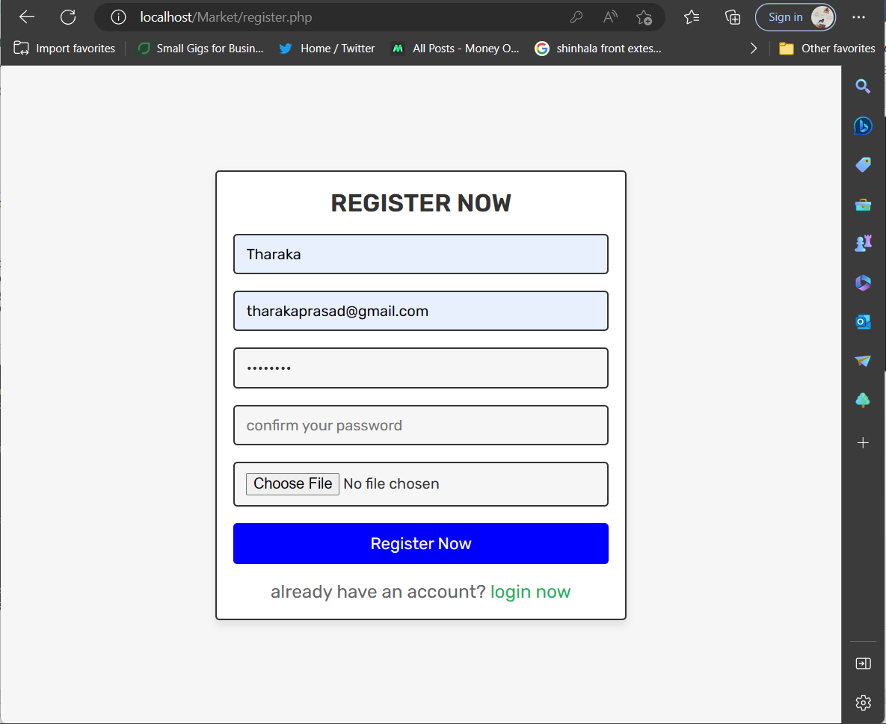

## Login

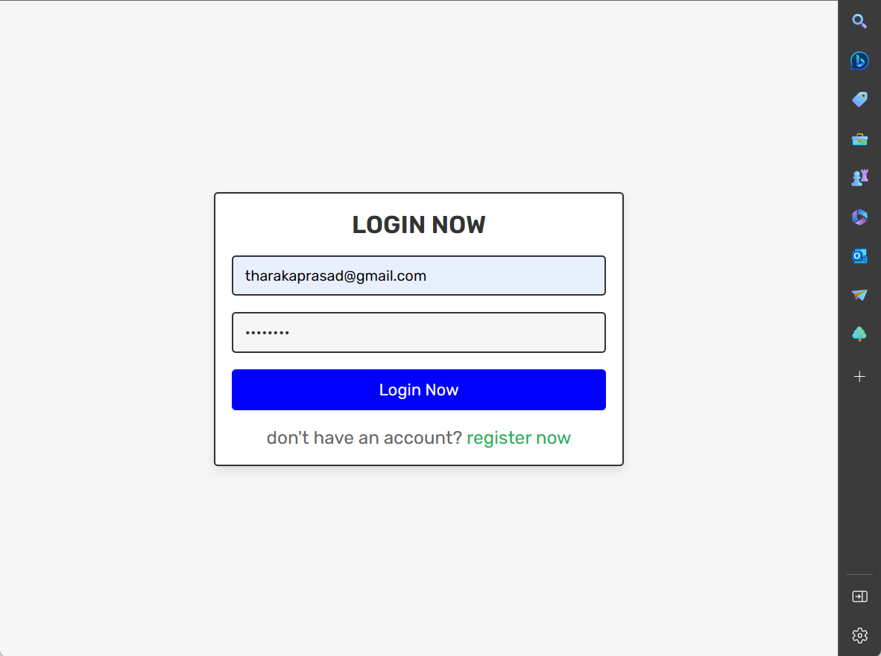

# User page

## Home page

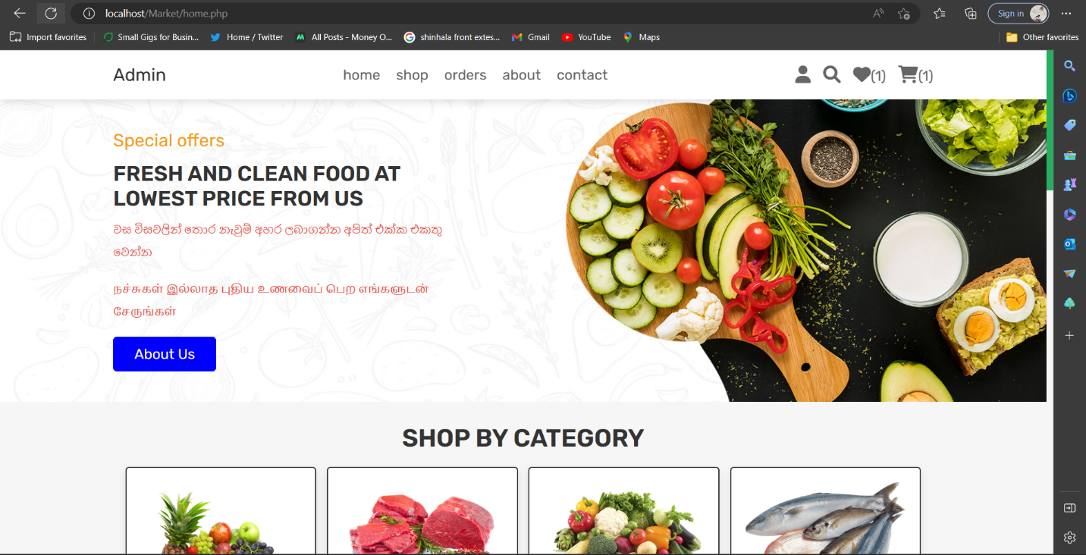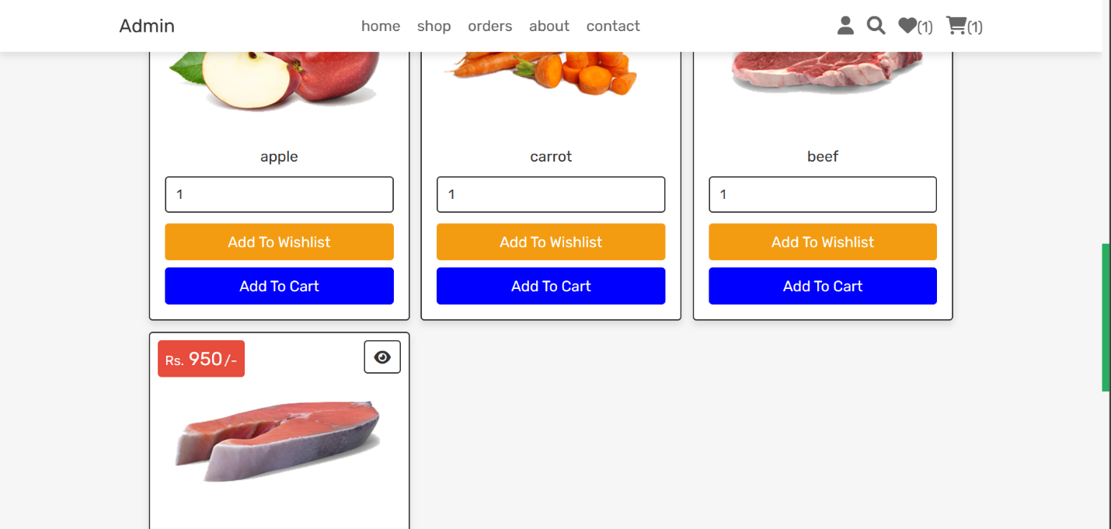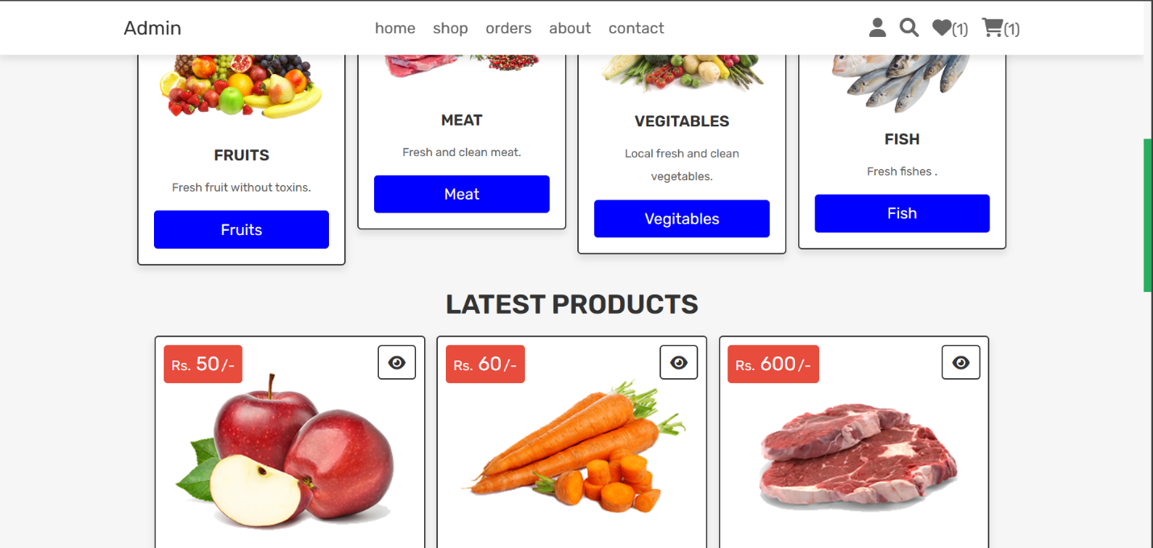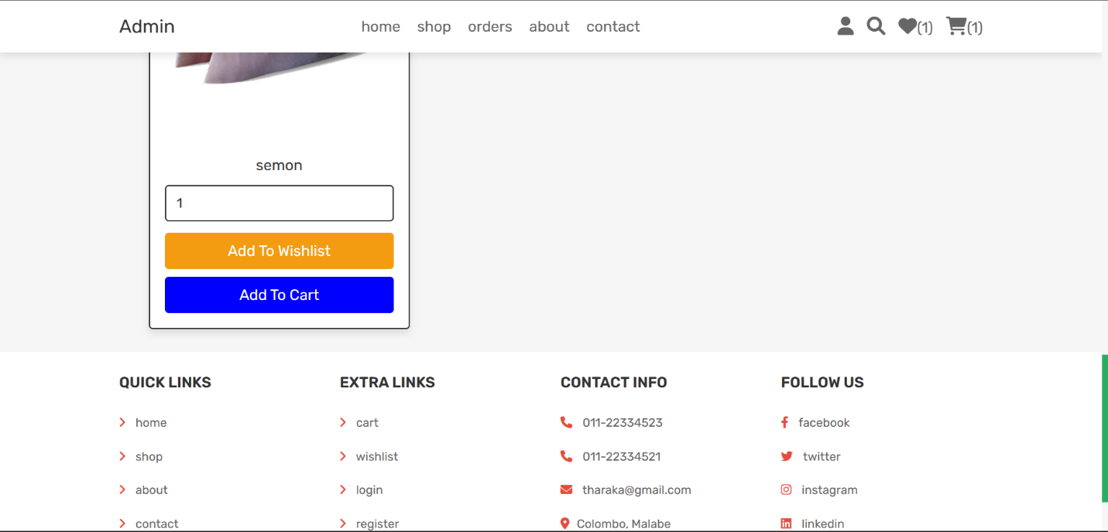

## Shop page

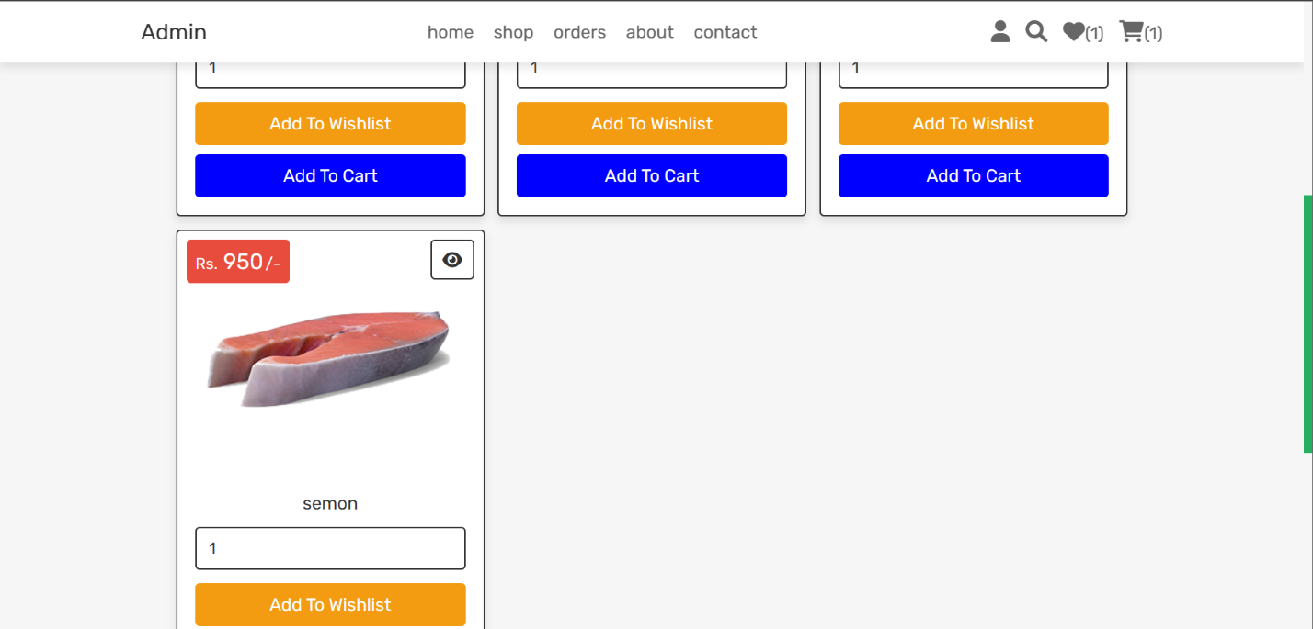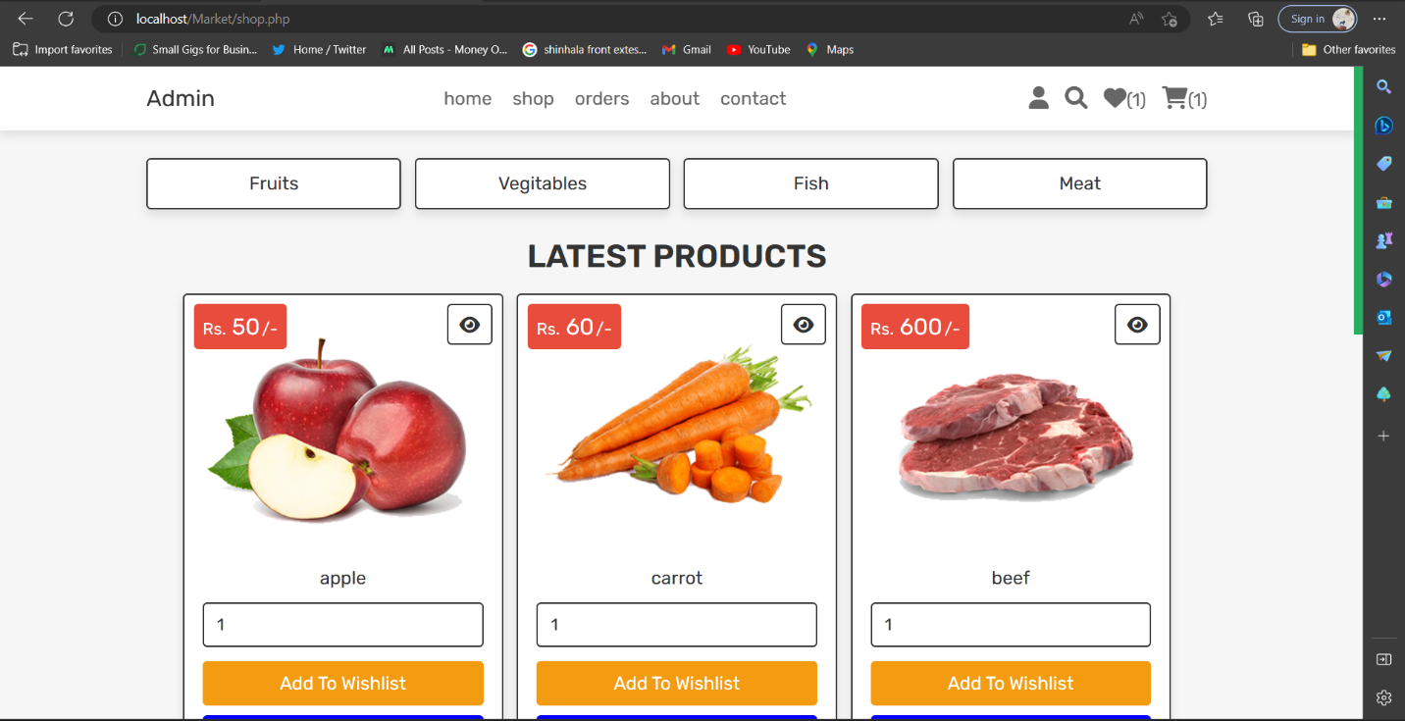

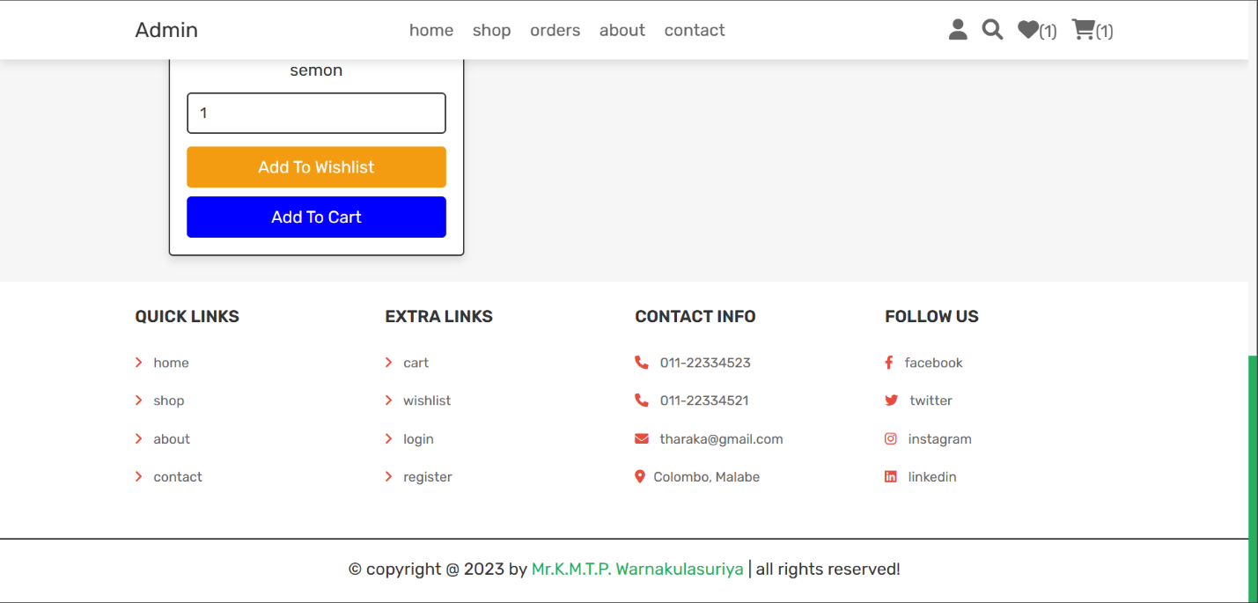

### Fruit page

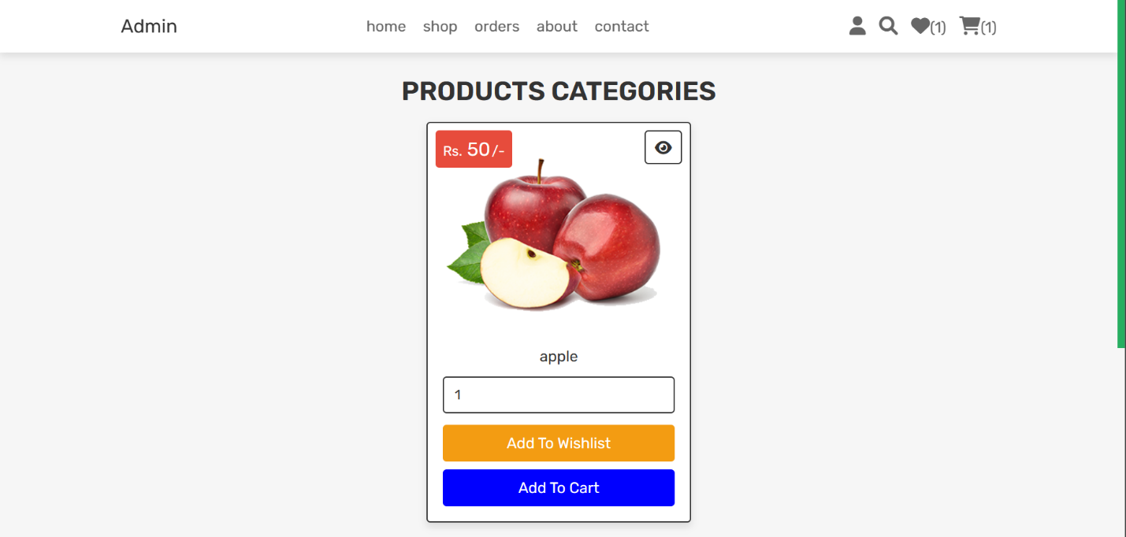

### Vegetable page

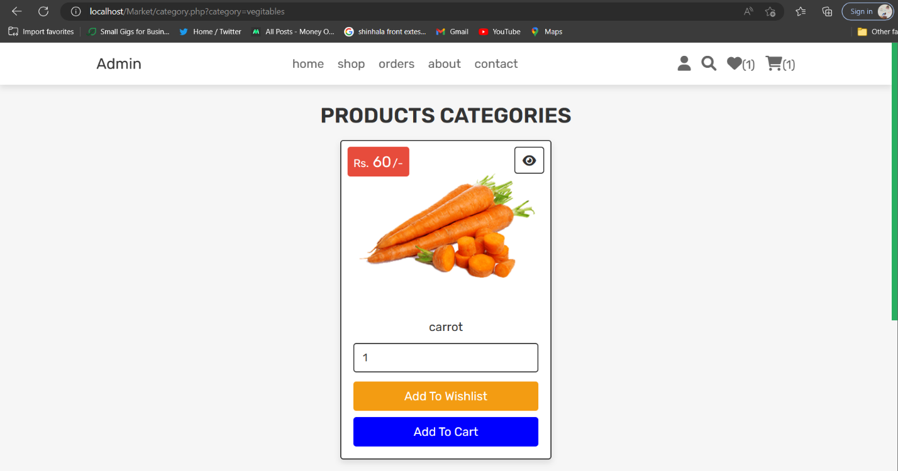

### Fish page

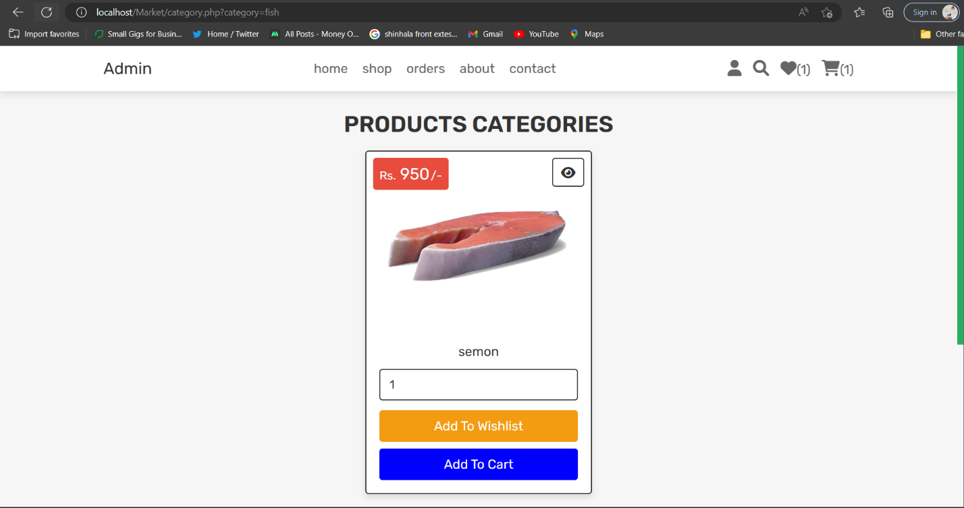

### Meet page

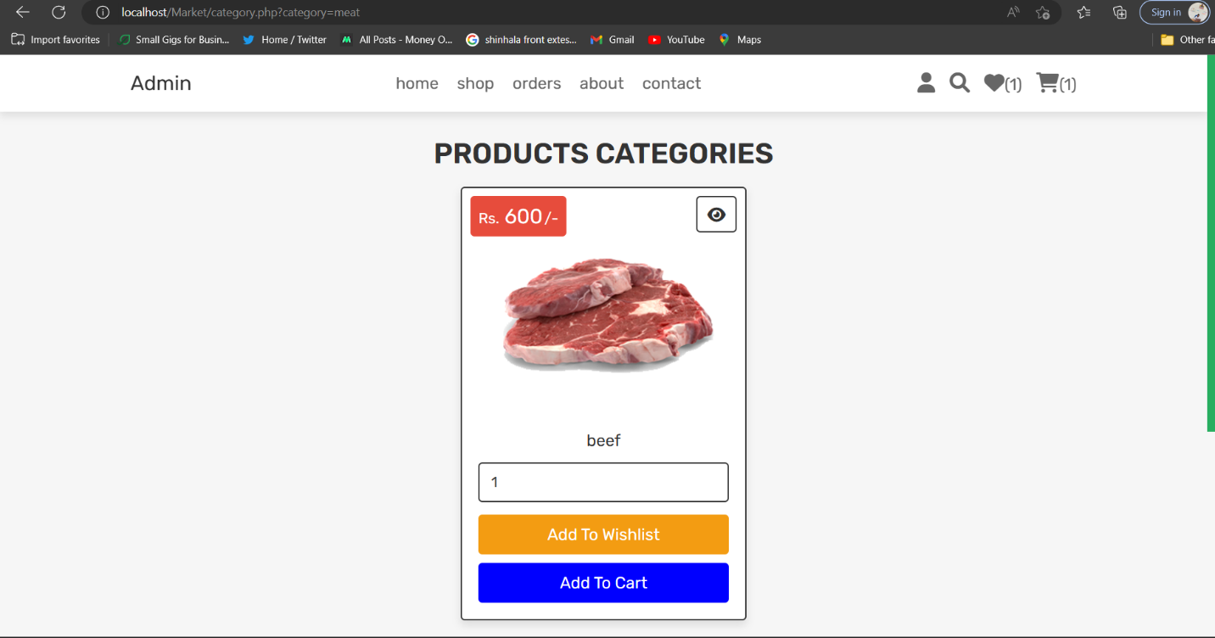

## Order page

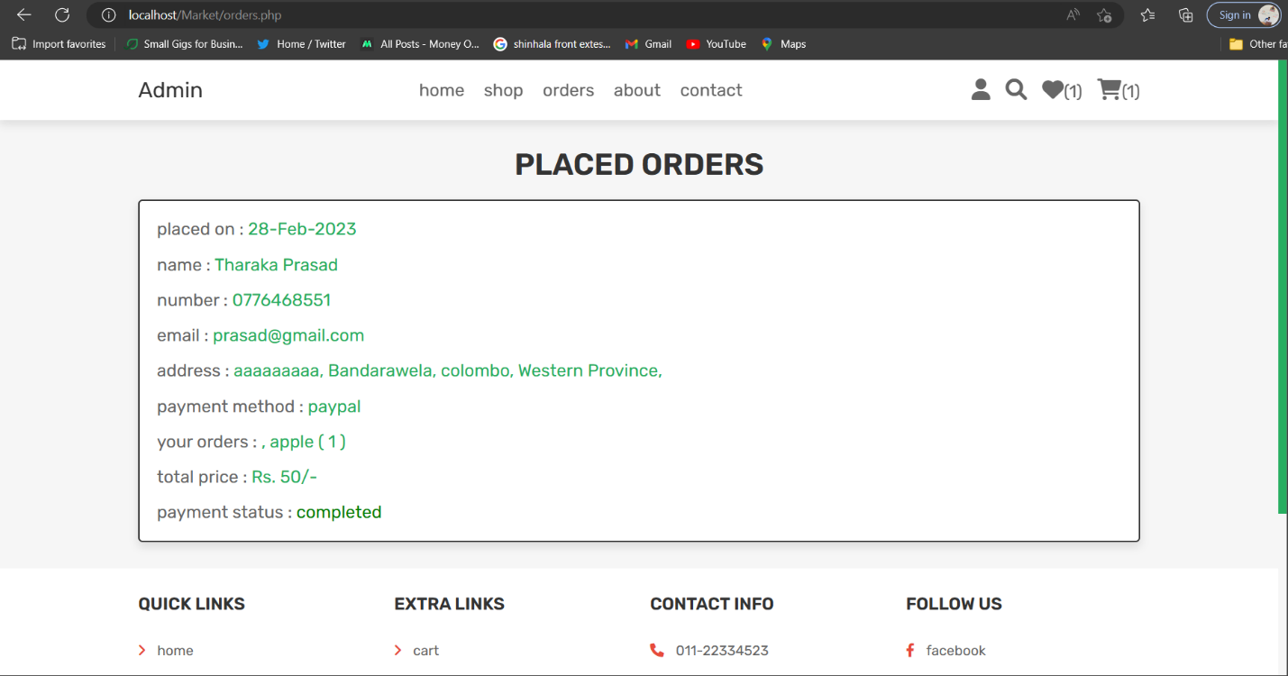

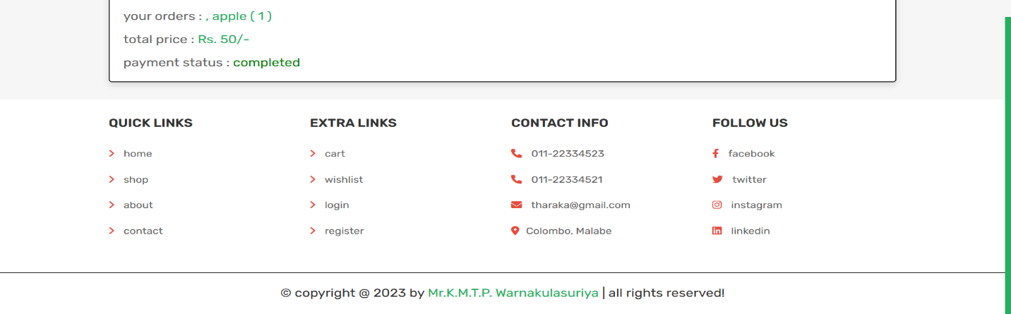

## About page

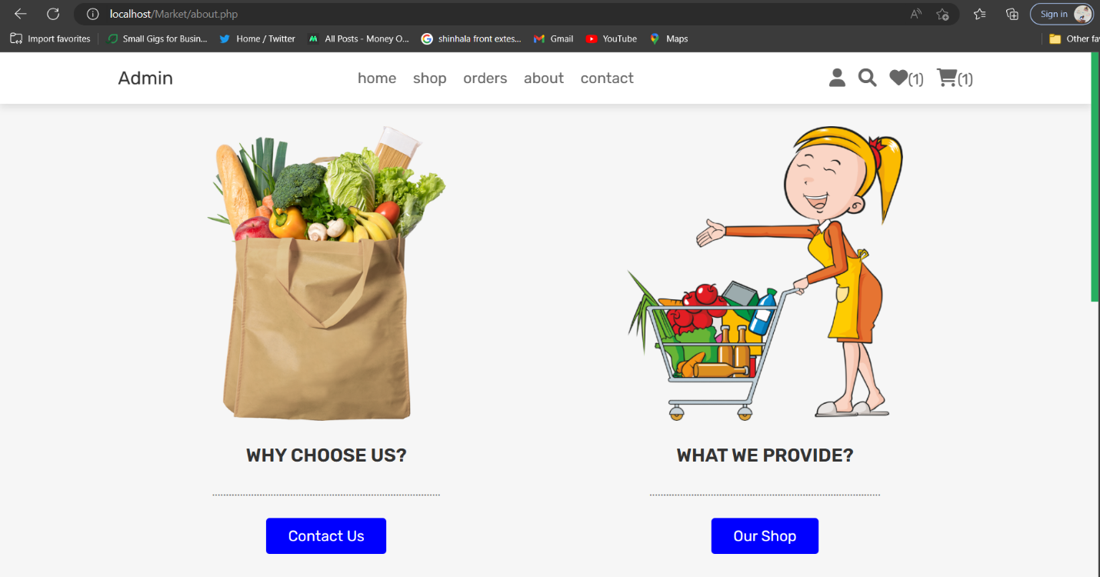

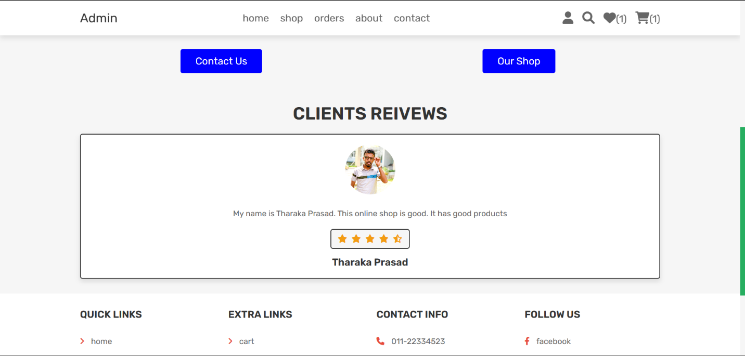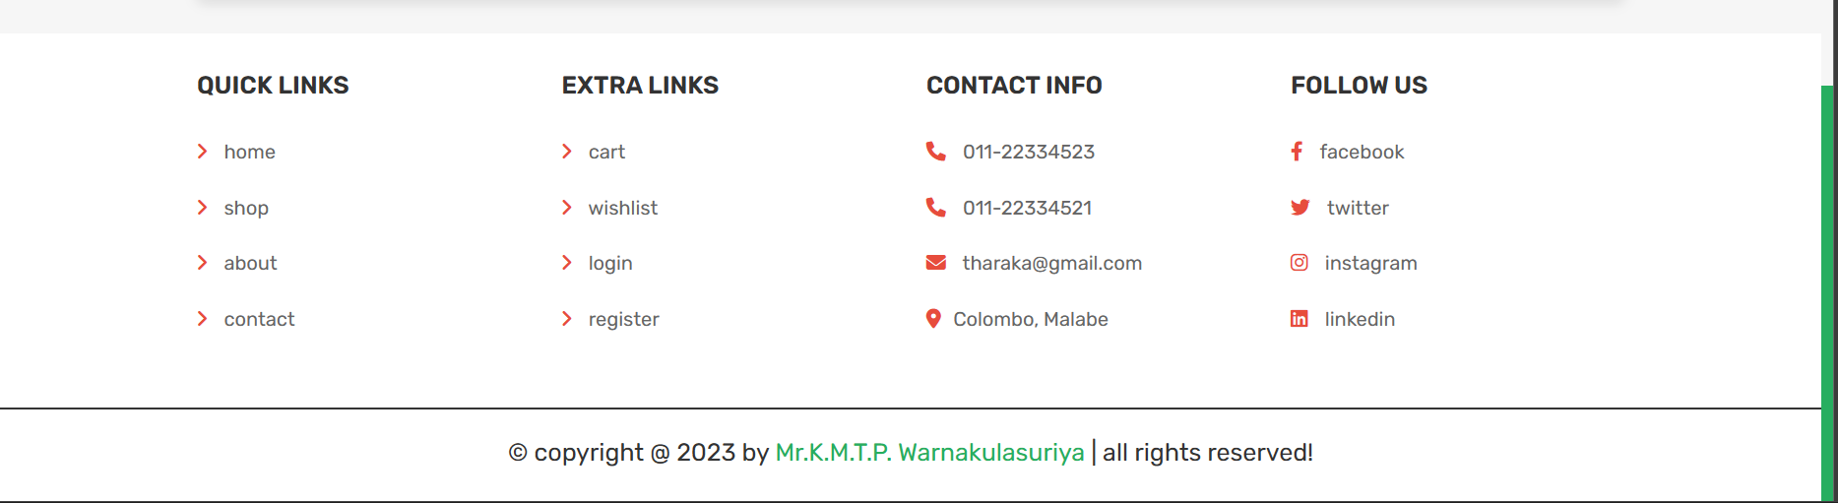

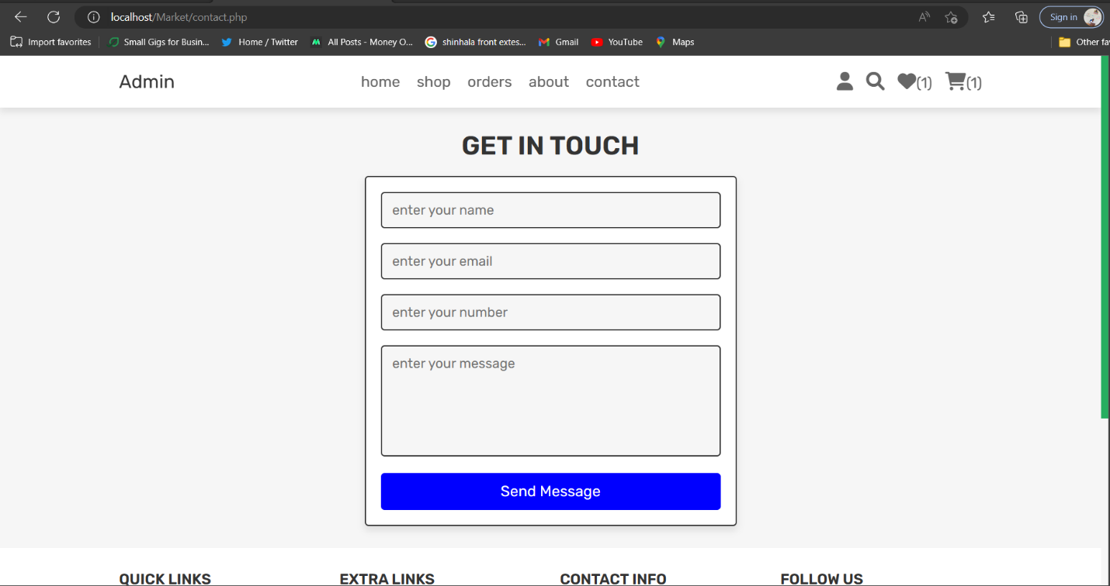

## Contact page

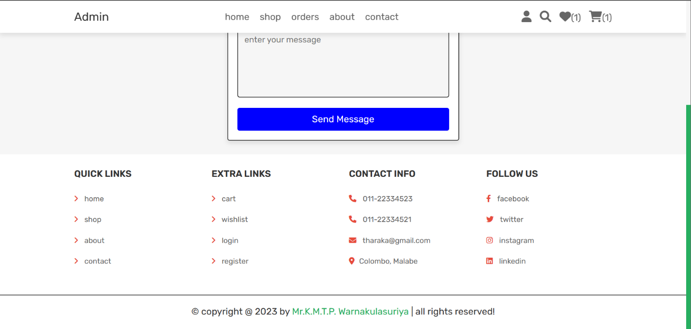

## Profile page

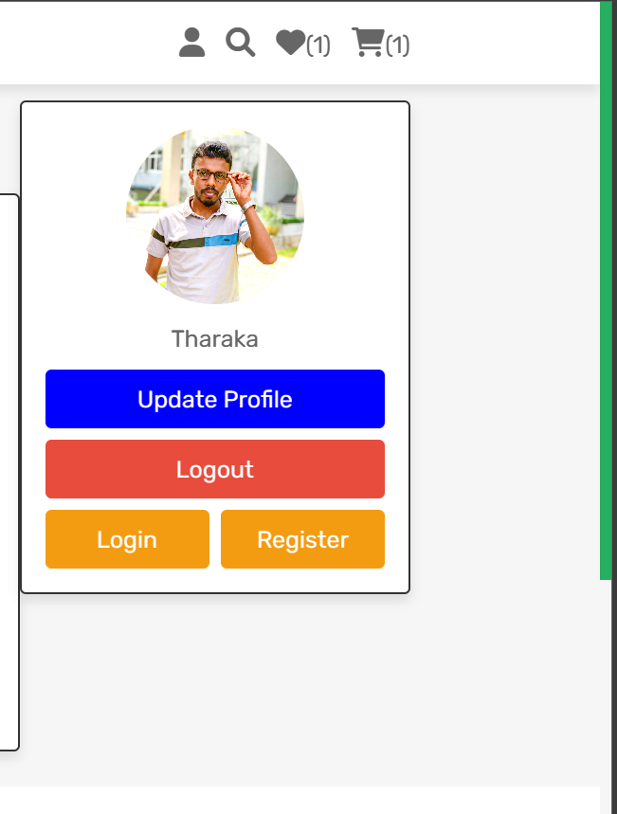

### Update profile page

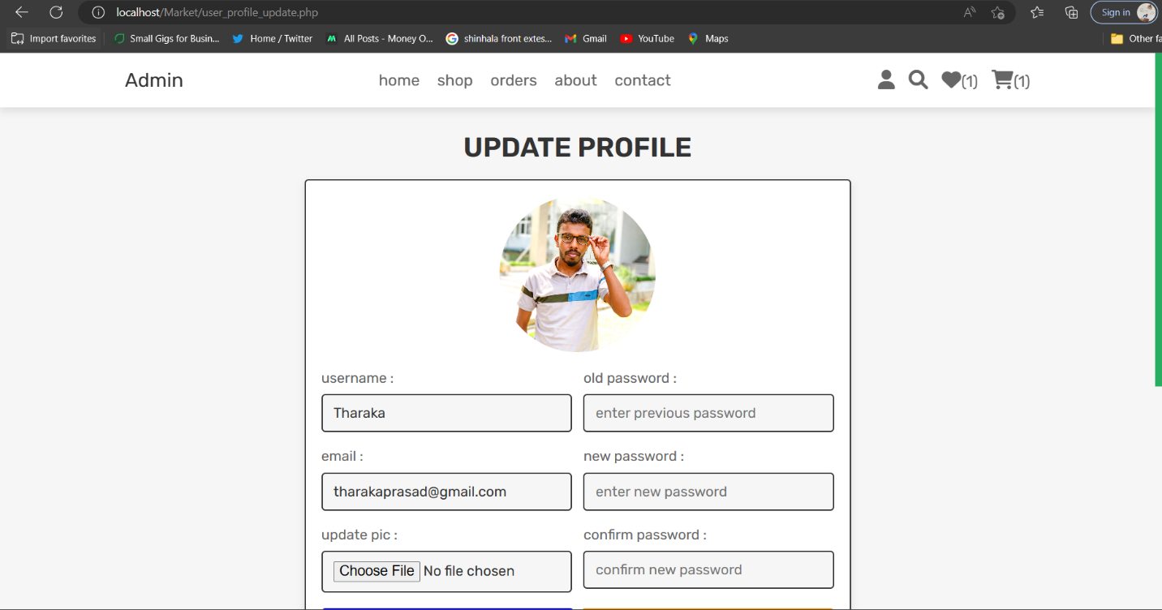

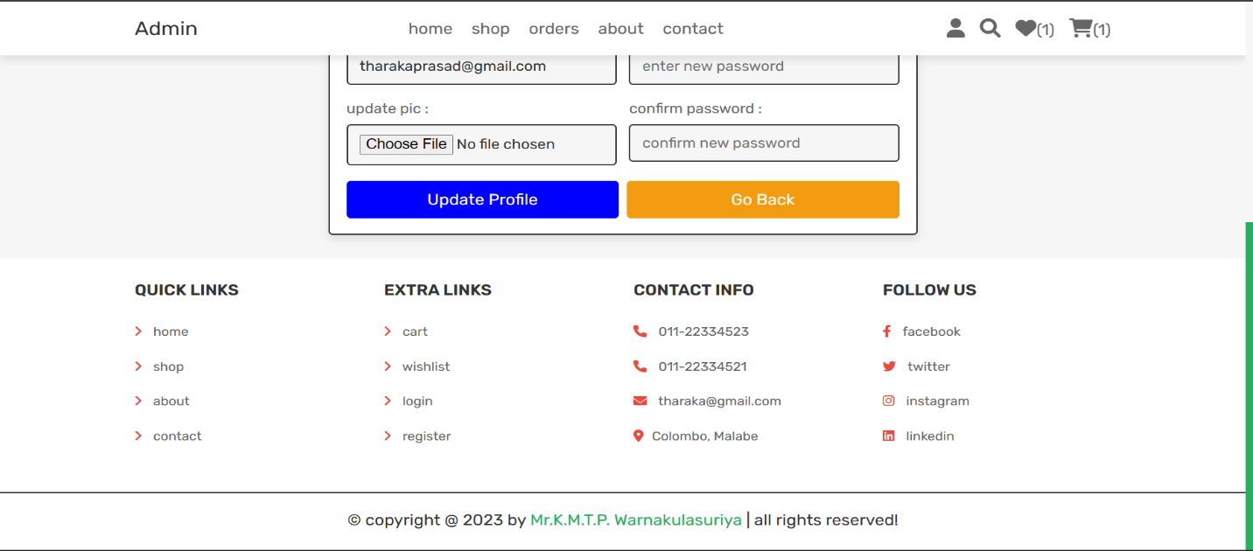

## Search page

## 

## Wishlist page

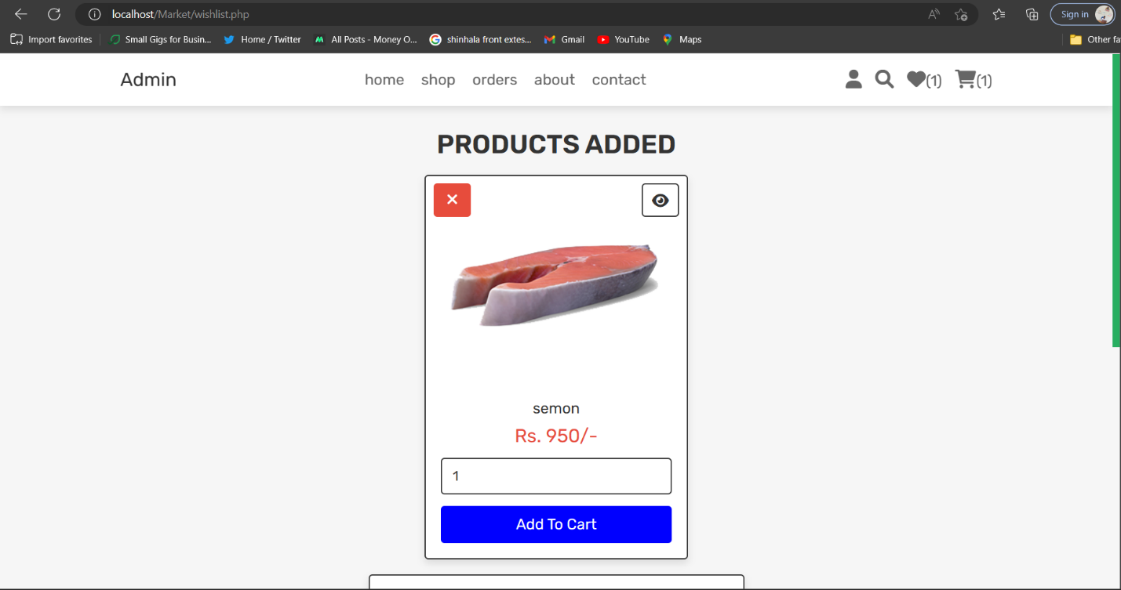

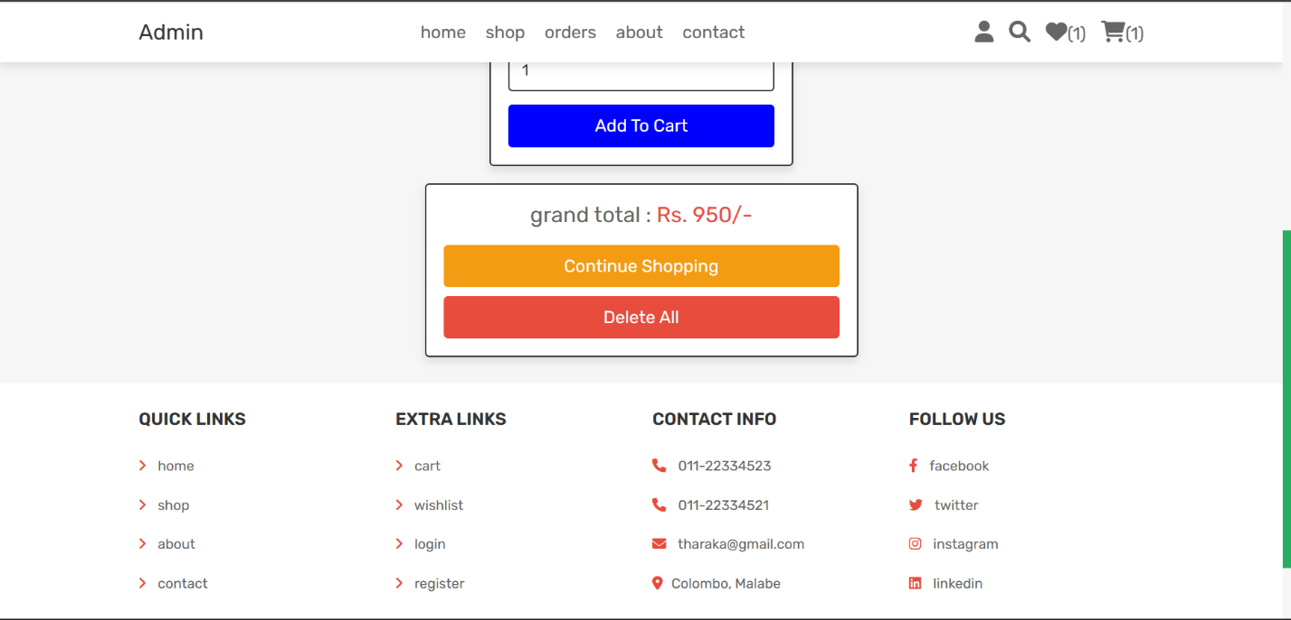

## Cart page

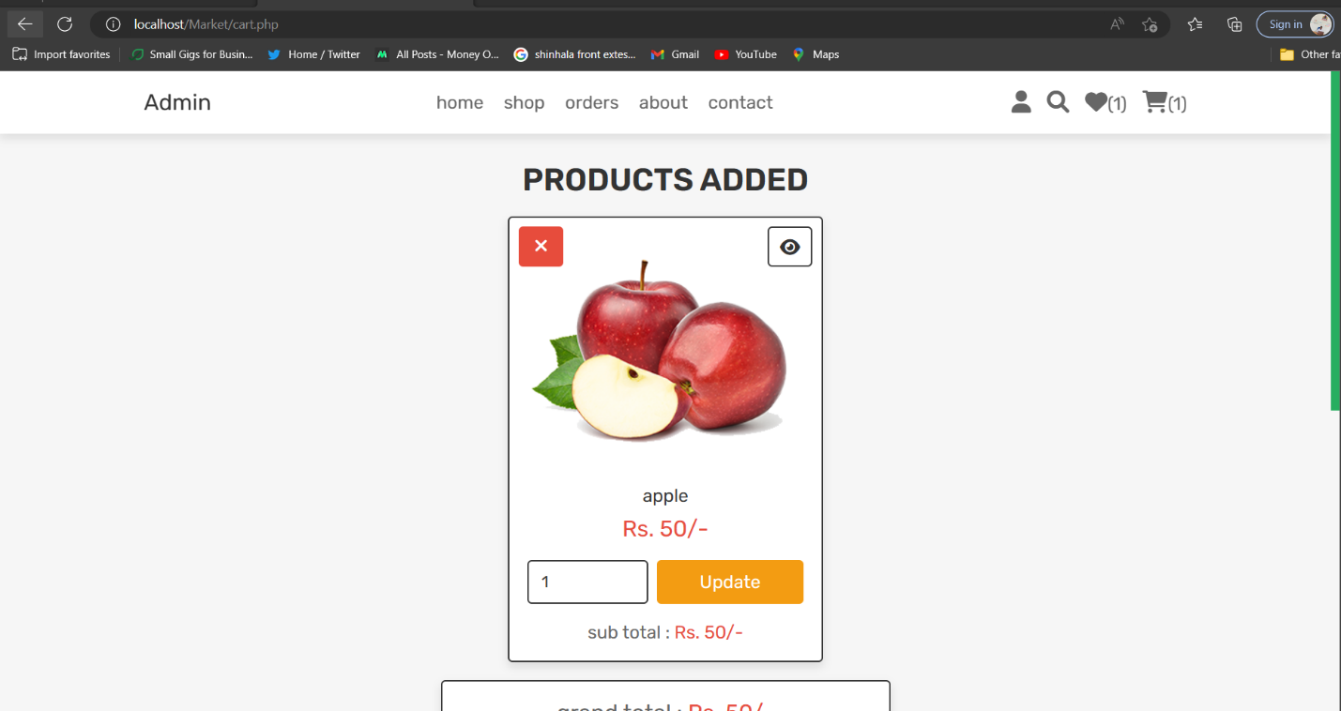

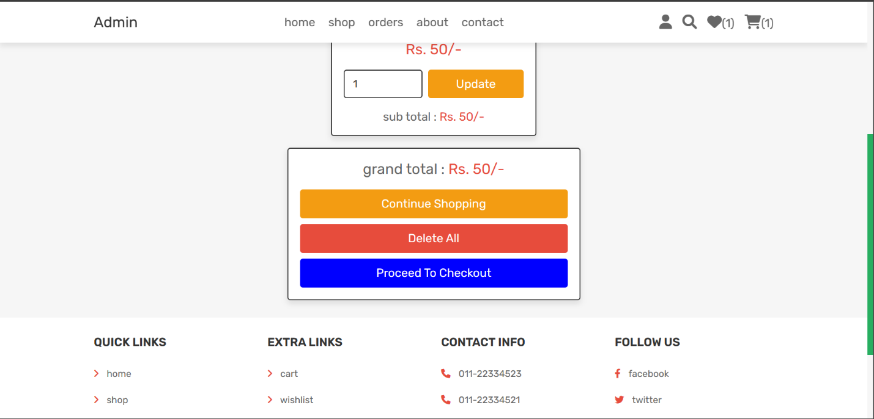

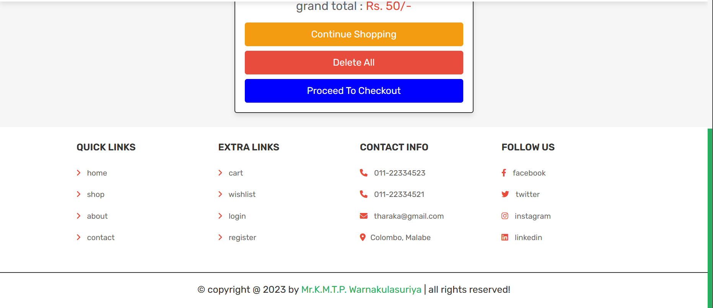

### Process checkout page

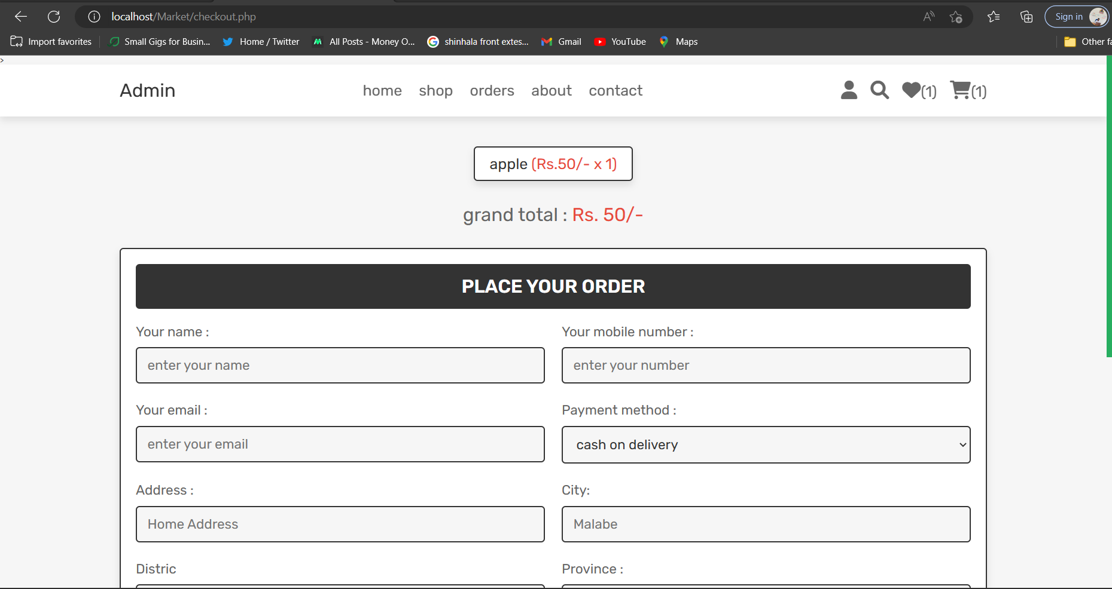

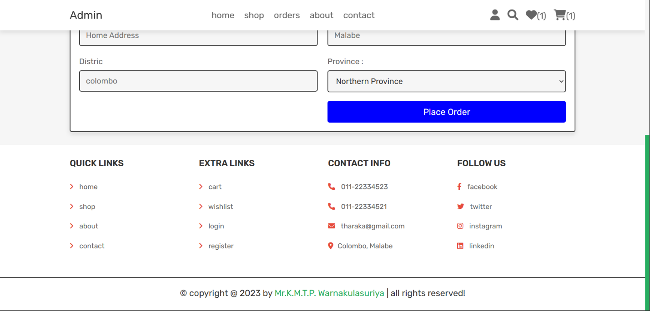

# **Admin page**

## Home page

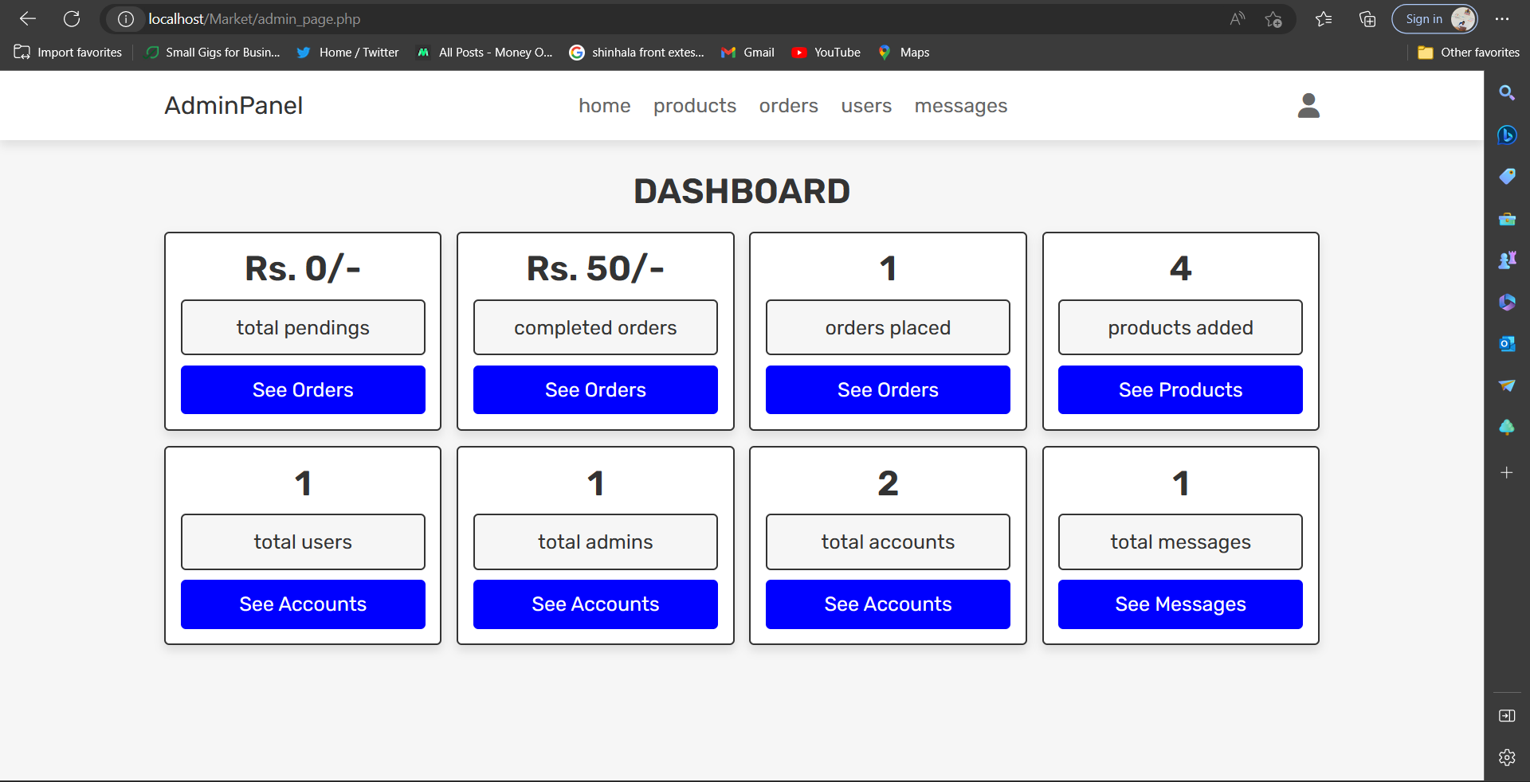

## Product page

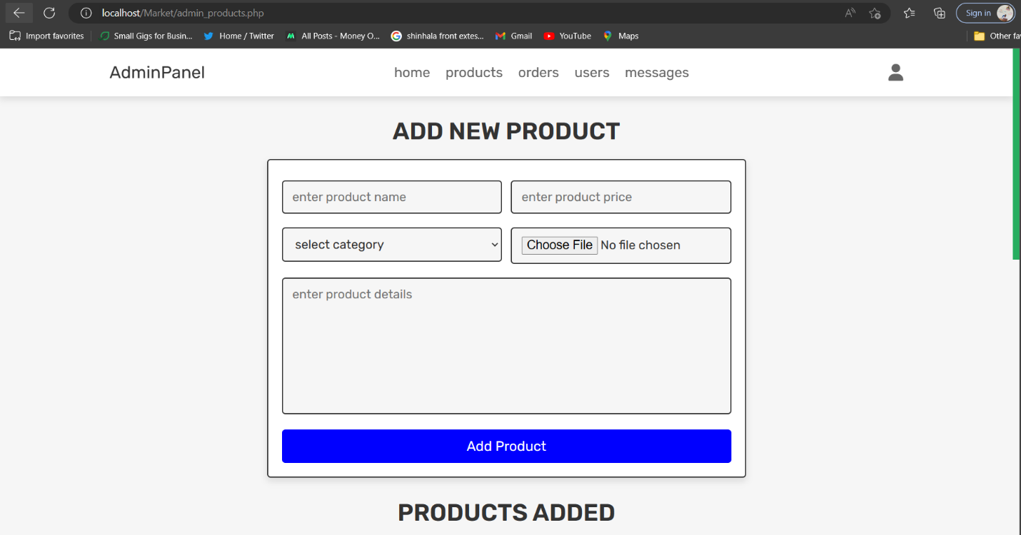

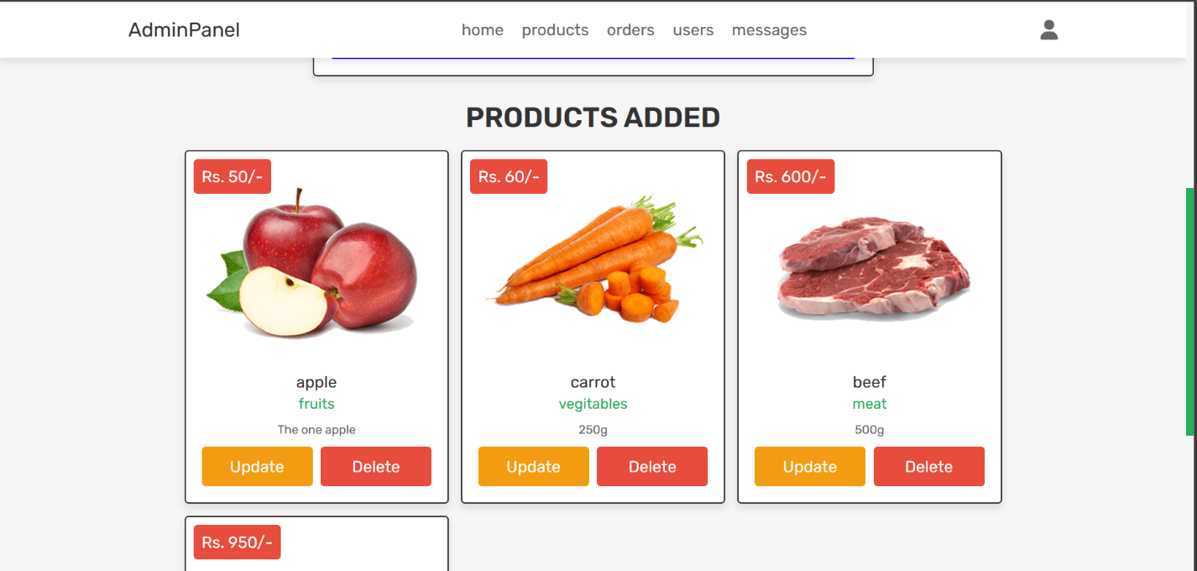

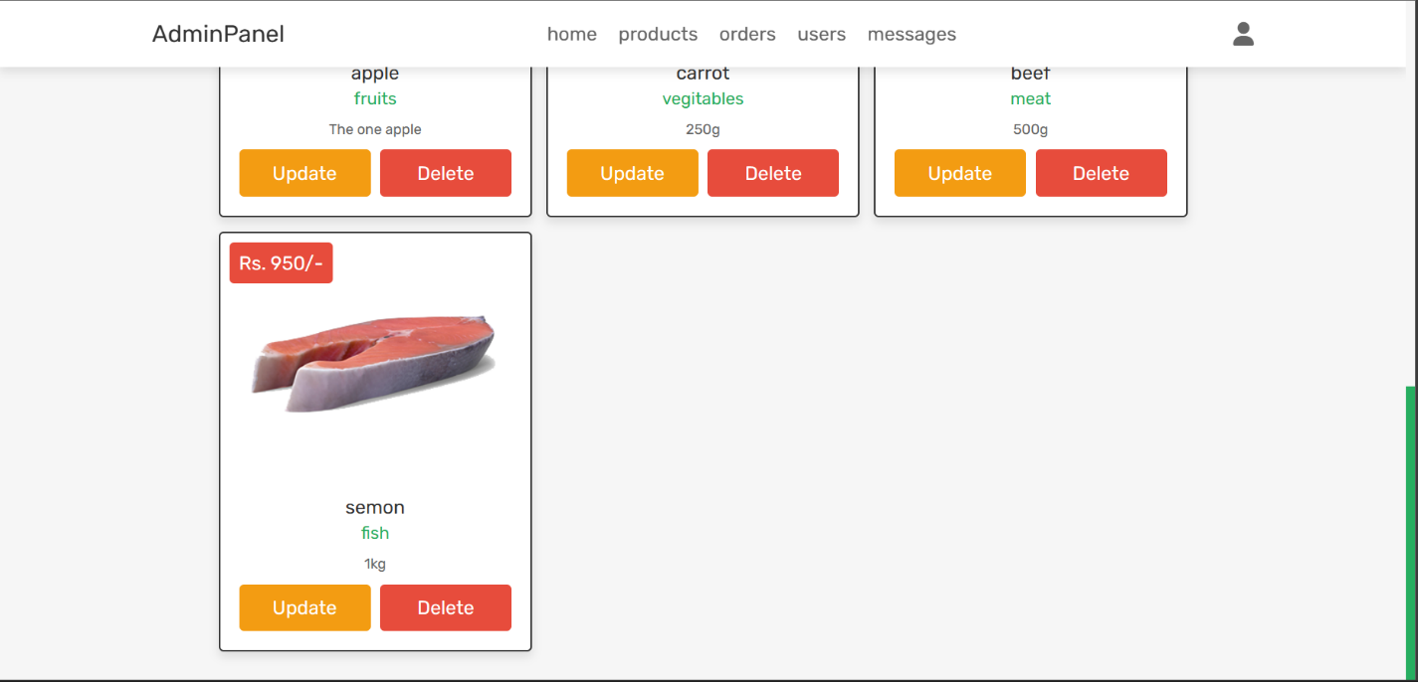

## Order page

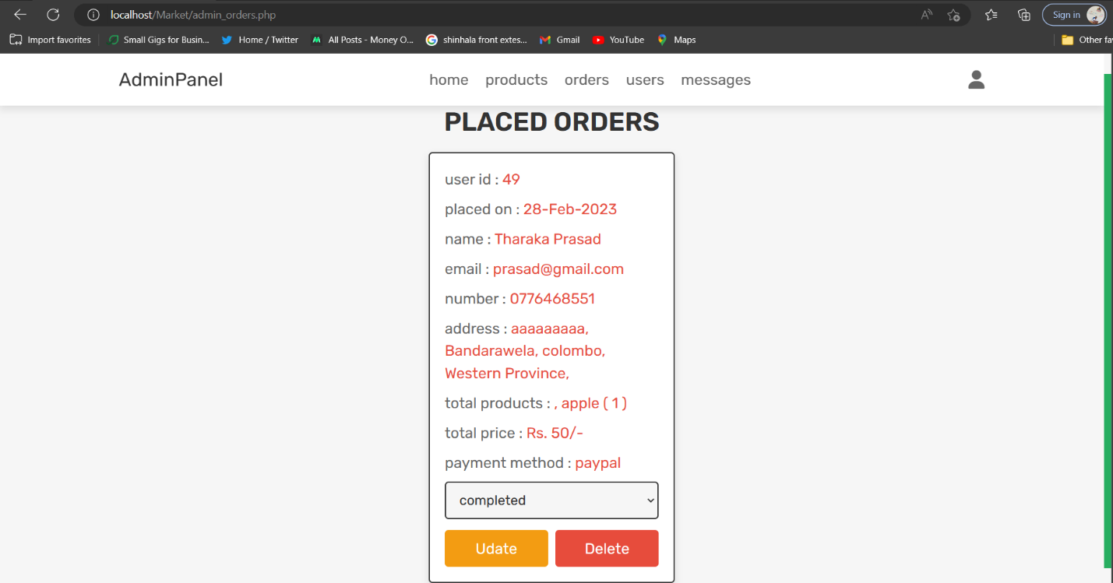

## Users page

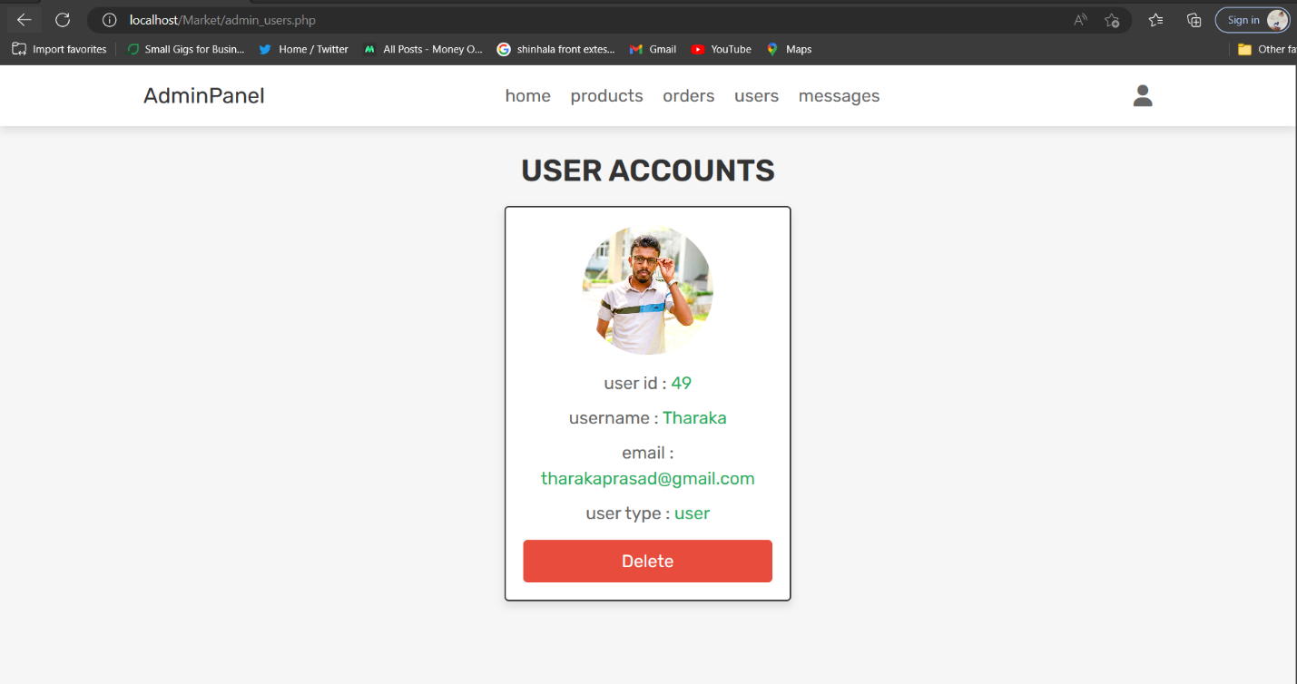

## Massage page

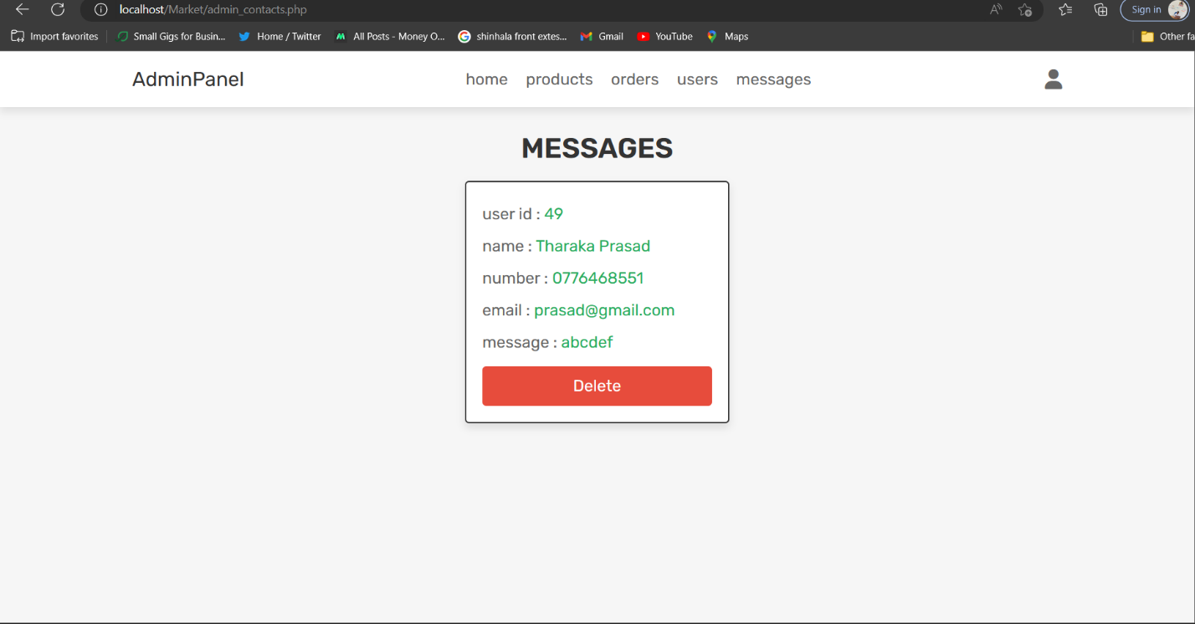

## Profile page

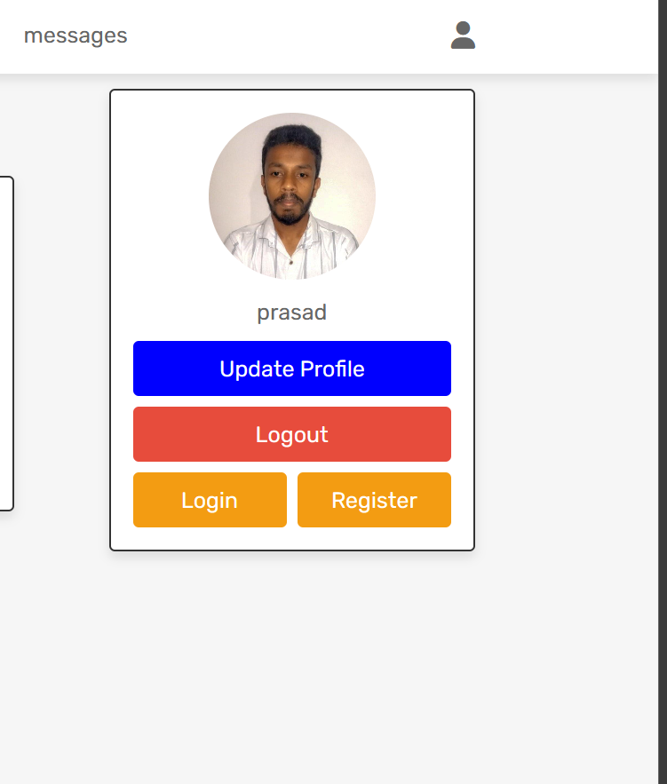

### Update profile page

